# Analysis of HSE[1] students’ relationships using graphs (based on VK[2] data)

## Preface

I don't remember what motivated me at the very beginning, but most likely it was something like "Get data about all the students of HSE? That sounds fun!" I just wanted to see how the students are connected to each other, what Internet communities they’re subscribed to, and then quickly write a review article.

However, due to "what if I consider something extra?" and errors in the code, "quickly" turned into 2 weeks, and my initial desire to just make a visualization was supplemented by more analytical one - calculate some metrics that would characterize students of different majors and years.

## Introduction

In this article, I will provide a visualization (in the form of graphs) of how HSE students are connected to each other, and also give these connections some characteristics (since this is just data retrieved from a social network, by connection I mean the presence of people in each other's friend list, and in this regard it is very important (for subsequent interpretation) to clearly indicate this fact).

If two people are on each other's friend list, it does not mean that they:

* consider each other friends in reality
* they communicate well
* know each other offline

In addition to visualization, I will consider the results of applying some metrics that can be used to compare student communities with each other.

### Content:

* Introduction
* How the data was extracted
* Definition of graph
* Graph layout
* Metrics used and their interpretation
* Oriental Studies
* Design
* History
* Logistics
* Management
* Political Science
* Sociology
* MAPS (Management and Analytics in Public Sector)
* Philology
* Economics
* Law
* Comparison of some faculties by different metrics
* Average number of handshakes
* Most “inclusive”
* Comments

## How the data was extracted

Almost all HSE students are subscribed to the VK community of their *university group*[3] (for example, [this](https://vk.com/asianstudies2018) is a group of third-year students majoring in Oriental Studies). Unlike this one, most of the groups are closed, but their participants are still visible.

And then everything goes quite simple:

* If a person is subscribed to only one community of one educational program, for example, a particular academic group of third-year students of Oriental Studies, most likely he/she is a third-year student of Oriental Studies.
* If a student is subscribed to communities of only one educational program, for example, 2nd and 3rd years of Philology, this student belongs to the senior year (in this example, the 3rd year), since there are much more senior students who want to look at junior students (and thus the former are subscribed to a community of the latter) than there are junior students who want to look at senior students.
* If a person is listed in the “contacts” section of a certain community as a *curator*[4], he/she is considered as a student of this educational program but one year older than the students of this group (it sounds complicated, but in a way, it is). In other words, for example, a curator of students of the 1st year of Design is a student of the 2nd year of Design.
* If a person is in groups of more than one educational program, I had to solve it by hand — either ask friends (thank you all who helped!), or (when I realized there’s such possibility after the advice of my classmate) look at the names and surnames in the ratings of HSE (they are publicly available). Fortunately, only about a hundred students fell into this category.

Speaking of how I retrieved the data, I did not consider an educational program "Applied Mathematics and Computer Science", because, as far as I know, they have only one community (one academic group) on VK.

Unfortunately, the access to web-pages of a number of students is restricted (know that if your page is closed for no good reason, I don't like you), so their friend lists are not available, but to detect a connection between students A and B, I need at least one open account (either A or B). But if both accounts are private, I’m not able to conclude whether they’re connected.

Of course, some students might have been identified incorrectly in terms of their year at the University (and less often – in terms of their educational programs, for example, in case of transferring), and some connections could not be detected due to the presence of private accounts, but even with these errors, the data is, in my opinion, sufficient for close-to-reality visualization, as well as meaningful conclusions based on it.

## Definition of graph[5]

(If you understand what a graph is from a mathematical point of view, you may move on to the next section).

Speaking informally, graph is a set of vertices (in our case, students) that are somehow connected by edges [in our case, the presence of an edge between two vertices means that these two students (vertices) are on each other's friend list].

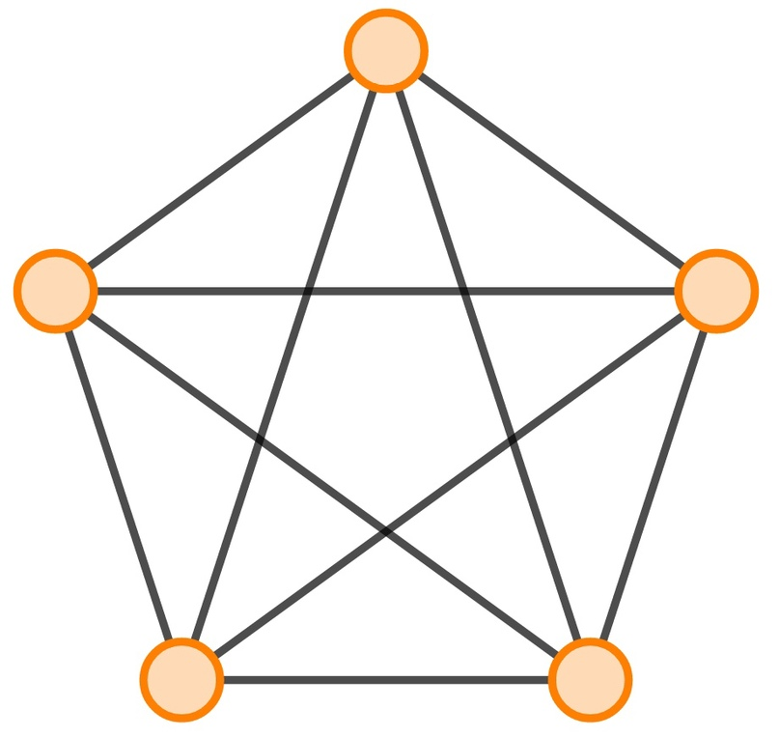

Strictly speaking, the graph **G** is given as **G = (V, E)**, where **V** is a set of vertices and **E** is a set of edges. A single isolated vertex can also be considered a graph, in which case we say that the set of edges **E** is empty. The graph can be weighted (then each edge has its own weight, for example, it can be the" importance " of a connection, or, say, if we were to consider a path between two cities, we could use the distance between them as the weight) or unweighted (the edges have no weight).

In the context of student connections, we will consider unweighted graphs (we only care about the connection between the vertices).

**Induced subgraph[6]** of a graph is another graph, formed from a subset of the vertices of the graph and all of the edges connecting pairs of vertices in that subset. (taken from the Wiki, I couldn't define it better myself). If you look at the picture above and leave only 4 vertices, then it will be something like this:

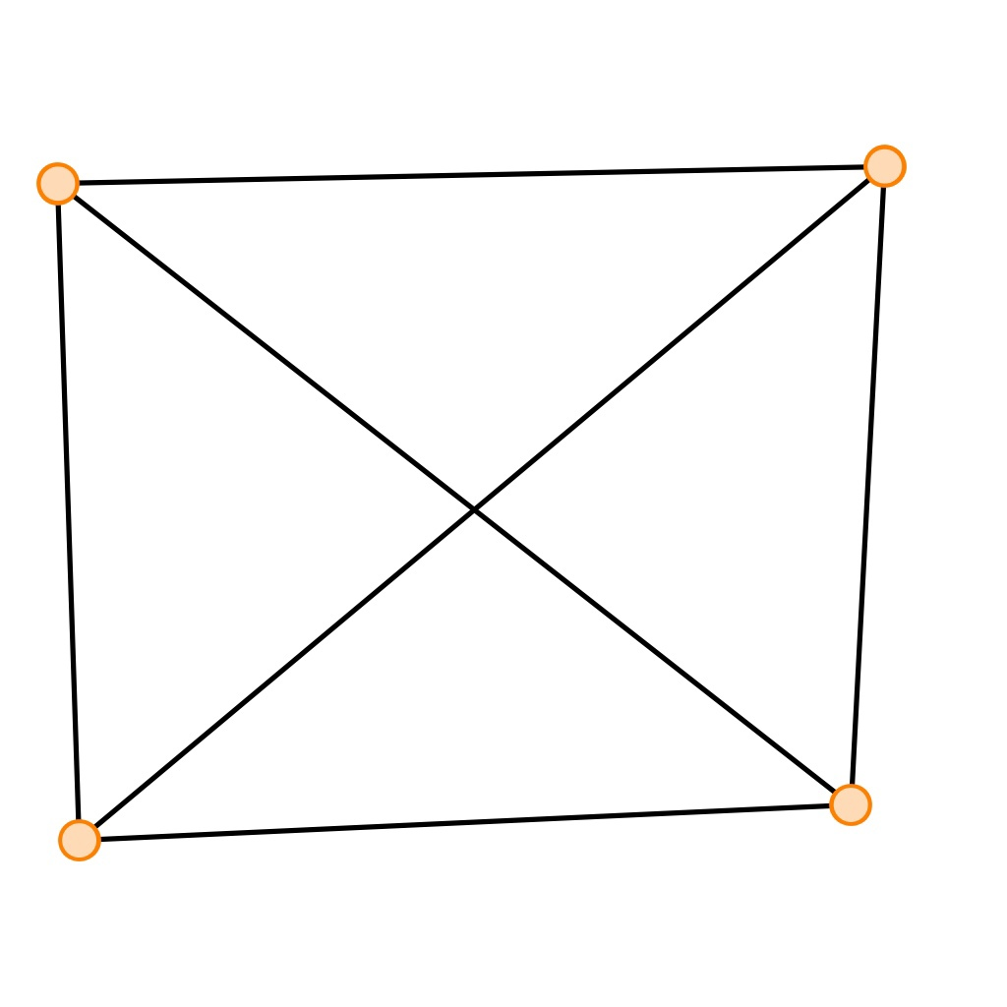

From now on, whenever I use the term “subgraph”, an induced subgraph is implied.

## Graph Layout

The graph can be drawn in more than one way:

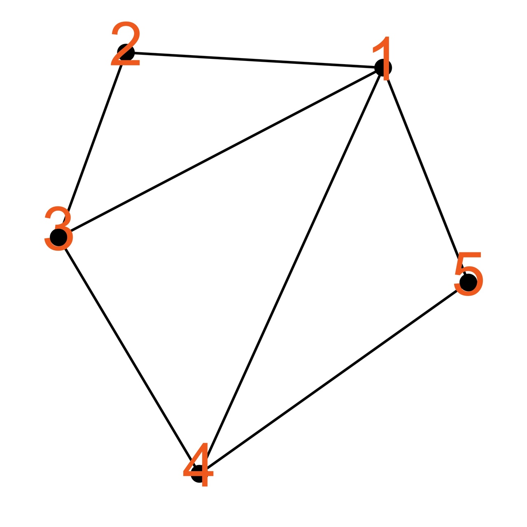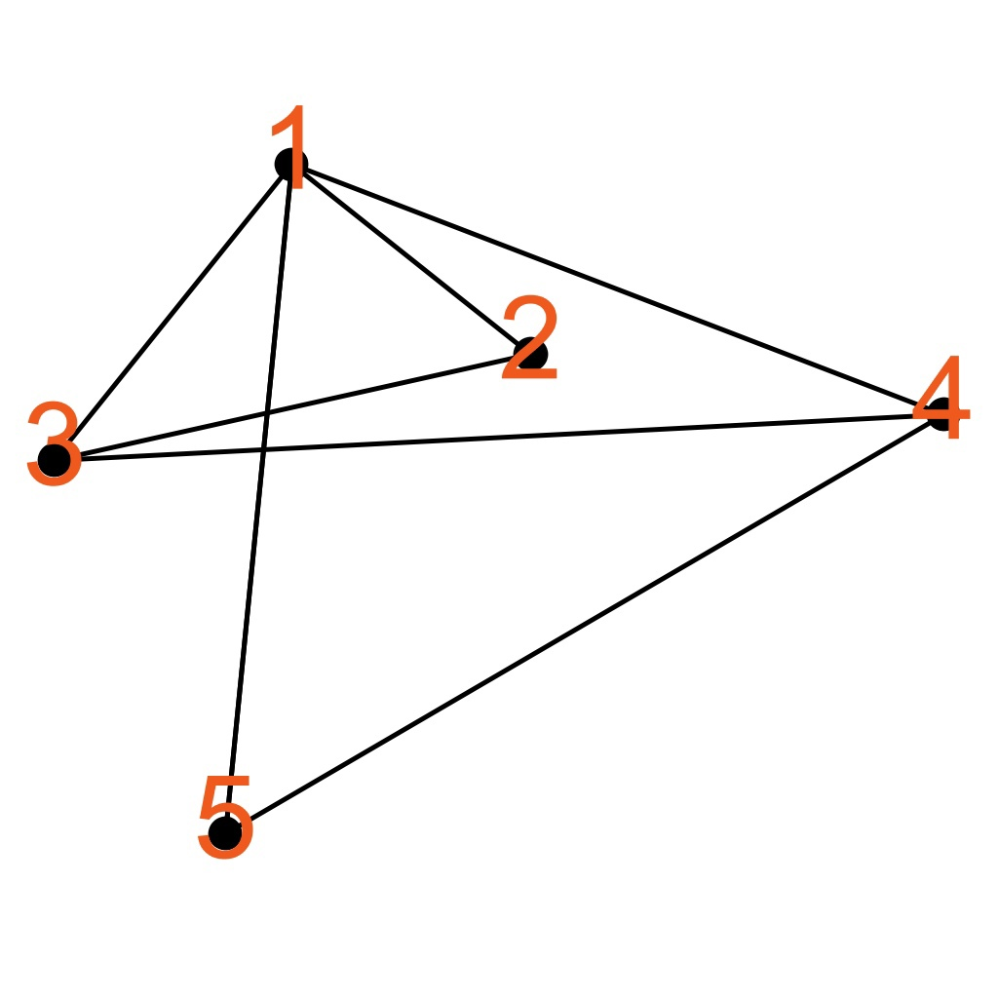

The images of the graph are visually different, but they are essentially the same (strictly speaking, they are isomorphic): The 5 vertices of the first graph are connected in the same way as the 5 vertices of the second graph (the same 5 vertices).

**Layout** — the visual arrangement of the graph vertices in a certain way relative to each other. The graph can be laid out in different ways, pursuing different goals, aesthetic or practical, and we will focus on the latter (although, in my opinion, it is still not without beauty).

For visualization, I use the [ForceAtlas2](https://journals.plos.org/plosone/article?id=10.1371/journal.pone.0098679) algorithm, which optimizes the modularity of the graph. If you want, you can read about modularity on the [Wiki page](https://en.wikipedia.org/wiki/Modularity_(networks)) (as well as in [this paper](http://kops.uni-konstanz.de/bitstream/handle/123456789/5853/modularity.pdf?sequence=1&isAllowed=y) or in the [original source](https://www.pnas.org/content/103/23/8577)), but in this article we will confine ourselves to a couple of sentences for general understanding.

**Modularity** is a measure of how much a subgraph of a given graph is a well-isolated community, and this definition may be generalized for the modularity of the entire graph (not just its individual subgraphs).

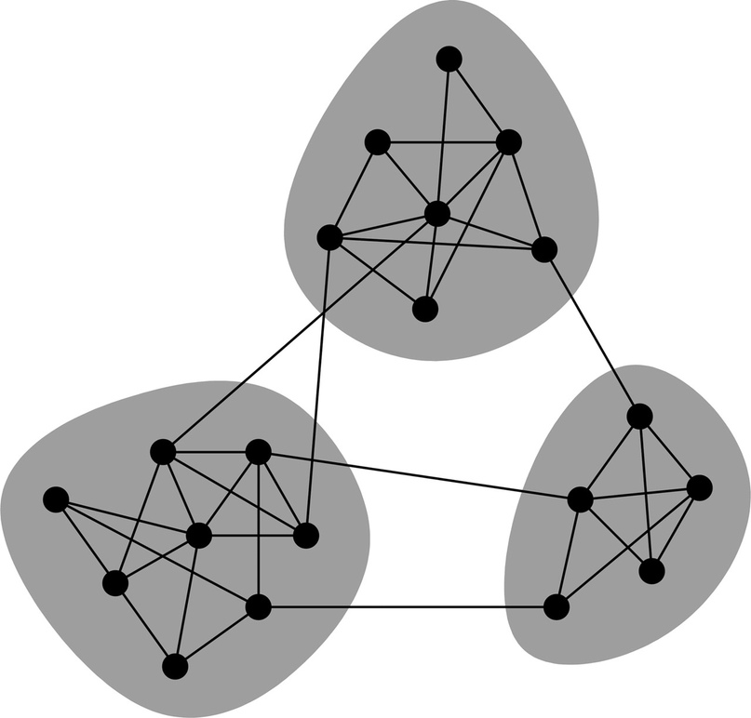Here you can look at the image on the left to understand the visualization: roughly speaking, the higher the modularity, the more connections within the clusters and the fewer connections between the clusters (in the picture on the left, there are 3 such clusters, and the given split maximizes (or at least optimizes) the overall modularity — there are “many” connections within the clusters, and there are “few” connections between the clusters. For an undirected unweighted graph (our case), modularity is a value within [-0.5; 1].

## Metrics used and their interpretation

(You can skip this section entirely and return to it if you feel it is necessary)

There is no universal metric for evaluating how “well-clustered” a graph is (how well it represents a whole community), and each has its own advantages/disadvantages, and can be interpreted in its own way.

So, I used 4 different metrics:

* Graph density [0; 1]
* Average network clustering coefficient [0; 1]
* Global clustering coefficient [0; 1]
* Average shortest distance over the graph [1; max(path)]

### Graph density

**Graph density** is a ratio of the number of edges of the graph to the number of edges in the complete graph on a given number of vertices. Simply put, the ratio of the number of existing connections between the vertices to the number of connections if all the vertices were connected to each other.

Formally speaking, for an undirected graph, the density lies within [0; 1] and is defined as follows:

$\frac{\left|E\right|}{\left|E_{complete}\right|}=\frac{\left|E\right|}{\frac{k\left(k−1\right)}{2}}=\frac{2\left|E\right|}{k\left(k−1\right)}$,

where **k** — number of vertices in this graph (=|V|); **|E|** — number of edges in this graph, **|E(complete)|** — number of edges in the complete graph on k vertices

The interpretation here is the rather obvious — the closer the density is to 1, the more possible connections are present (the more students know each other).  
Despite the fact that density can probably be called one of the simplest indicators of graph clusterization, this metric has two substantial drawbacks:

1. *It may be a poor choice when comparing graphs with a very different number of vertices.*

If you pay attention to the denominator of the formula, you might notice that it grows approximately as k2. So, if there are about 300 students majoring in Sociology in total, and slightly less than 900 students majoring in Management, in the denominator for Sociology will be a number much less than that of Management (3002 vs. 9002), so that the latter need much more connections between students in order not to lose to Sociology in terms of this metric (after visualization, it will be seen why this metric is a poor choice for comparing faculties (or students of a certain year between different programs) with a significantly different number of students, since it will be clear that a graph of each educational program is very far from being complete).

1. *It does not take into account the location of the edges.*

For example, these two graphs will have the same density (the number of vertices of the first graph is equal to the number of vertices of the second, the number of edges of the first graph is equal to the number of edges of the second one):

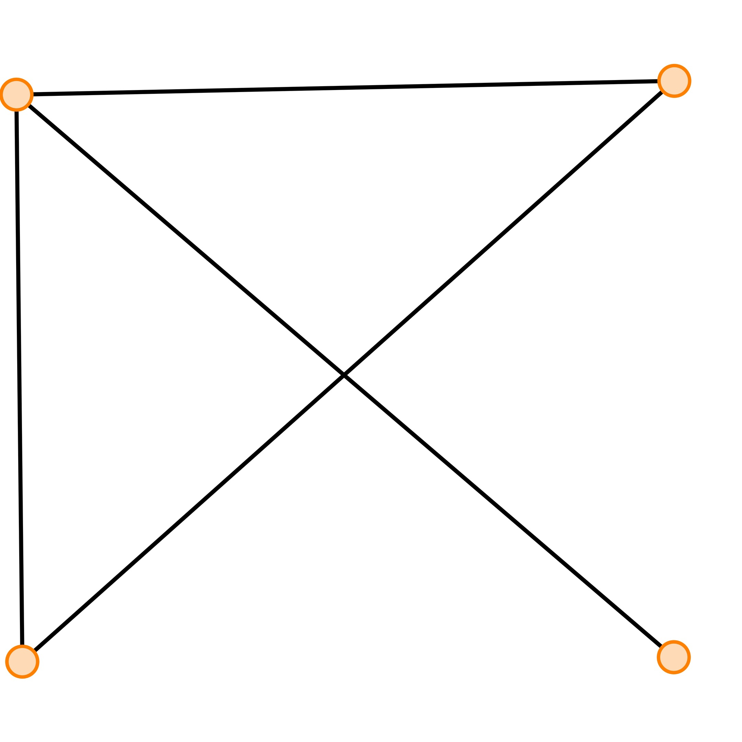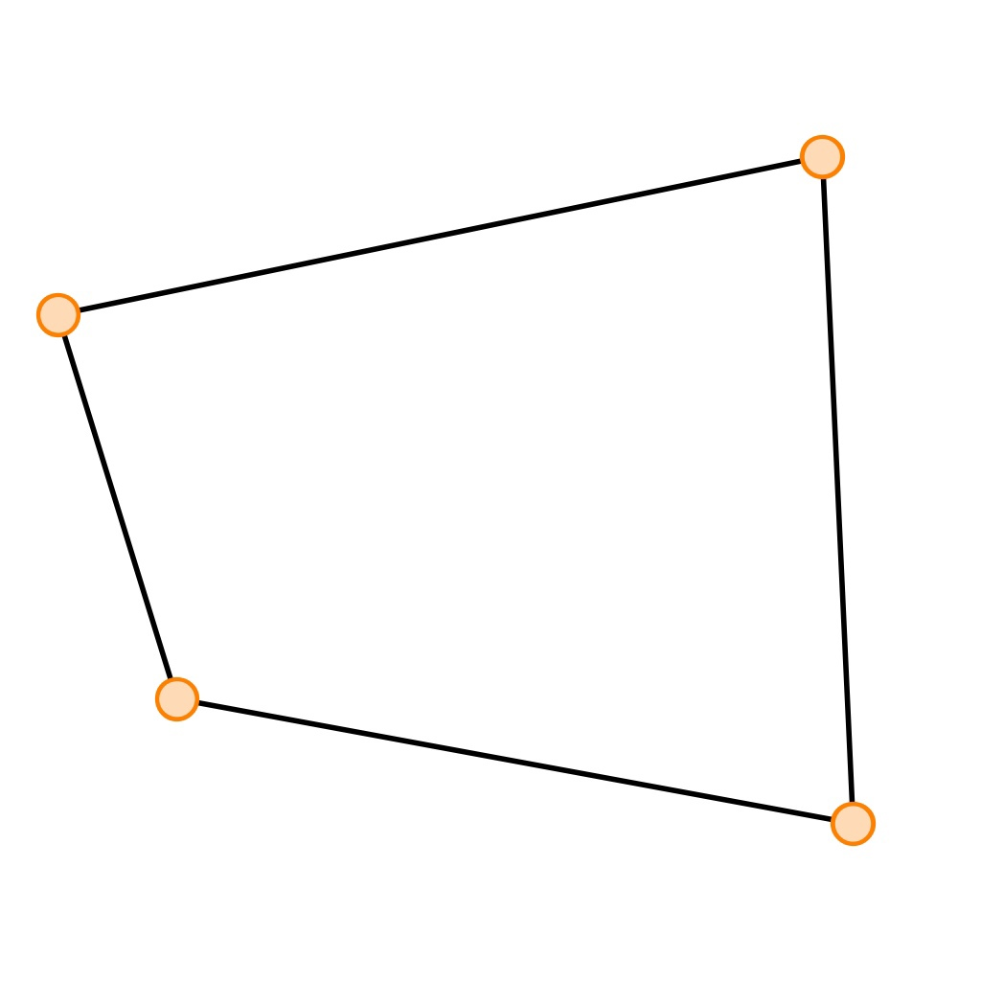

So, in the case of the first graph, it is reasonable to combine three vertices into a single cluster, and in the case of the second one — all the vertices, but as said, the location of edges is not taken into account when calculating the density.

### Average Clustering Coefficient[7]

Before defining average network coefficient, I will provide another definition on which the former is based.

**Local clustering coefficient7** for a given vertex i (denoted as Ci) is calculated as follows (using an example of students). Let's take a student, for example, Ivan, for whom we will calculate Ci, and look at all the students that Ivan has on his friend list.

Now, let's see how many connections there are between all of Ivan's friends such that both persons are on each other’s friend list. In other words, let's count how many pairs of Ivan's friends know each other. Then, we divide this number by the number of connections that would exist between all of Ivan's friends, if they were all familiar with each other. This is the local clustering coefficient!  
  
In other words, this is the ratio of the number of pair of friends of a given student that know each other to the hypothetical number of pairs of his friends, if they were familiar (sounds complicated, so the picture or a formal definition below might help).  
  
The local coefficient for blue vertices is provided on the picture on the left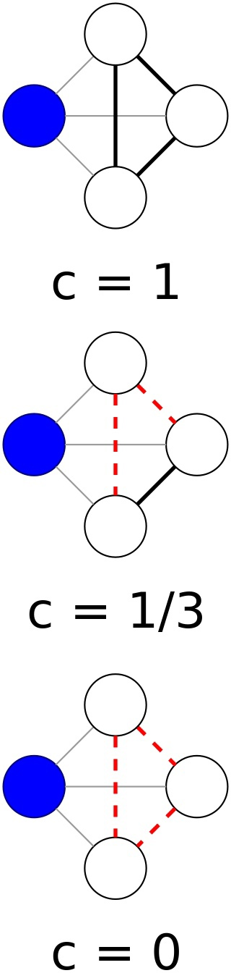. For the middle graph, out of the three "friends" of the blue vertex, only two know each other (i.e., there is only one connection), and there could be a maximum of 3 connections (3 friends are pairwise familiar), so the value of the local coefficient in this case is 1/3.

Formal definition:

$C_{i}=\frac{\left|\{e_{jk}:v_{j},v_{k}∈N_{i},e_{jk}∈E\}\right|}{\frac{k_{i}\left(k_{i}−1\right)}{2}}$,

where ejk – edge connecting vertices *j* and *k*; **vj –** vertex *j*; **vk –** vertex *k*; **N** (neighborhood) – set of all vertices connected to vertex *i*; **ki** – number of vertices connected to vertex *i* (=|Ni|)

**Average network clustering coefficient** is the average of local clustering coefficients over all the vertices of a given graph (surprise-surprise):

$\bar{C}=\frac{1}{n}\sum_{i=1}^{n}{C_{i}}$, where **Ci** is the local clustering coefficient for the i-th vertex; **n** is the number of vertices in a given graph.

The interpretation in the context of the students' analysis may be as follows.   
In fact, when calculating a local clustering coefficient (for a single student), we look at how strong the connection of all the friends of a given student is with each other (as a whole), how close they are to being acquaintances pairwise. Given that this coefficient is tied to a certain vertex (the student), we can say that this is a measure of how friendly is the company formed by students. Using this interpretation:

**Average network clustering coefficient** is a measure of how “friendly”, on average, the student companies are in the context of a given network (in the context of all “students-vertices” of a given graph)

Again, just in case, it's important not to miss the point. When I say "friends"/"friendly company", I mean it in a very specific sense. Do not forget that we are only talking about a network of contacts from a social network, not real friends.

Unlike density, *average network clustering coefficient* scales much better. Moreover, it takes into account how the vertices are connected to each other, and more weight will be given to those vertices whose *degrees* are relatively small.

**Degree of a vertex** is the number of edges that belong to that vertex. In the context of student connections, degree of a vertex (vertex — student) is the number of friends of the student (strictly speaking, the degree of a vertex is determined by the number of edges (not vertices-students), but the initial definition is valid in the context of this case).

In other words, students with a small number of friends will contribute on average higher values (closer to 1) than students with a large number of friends, because the chance that everyone knows each other in a small company is higher than the chance that everyone knows each other in a large one.

### Global Clustering Coefficient[8]

Before defining this metric, I will introduce the necessary concept of a *triplet*.

**A triplet** is three vertices, among which at least two pairs are connected by an edge. In particular, a triple of vertices forming a triangle (all vertices are connected) will be called a *closed triplet*, and a triple in which only two pairs of vertices are connected by an edge will be called an *open triplet*.

**The global clustering coefficient** is the ratio of the number of closed triplets to all triplets (closed and open).

For clarity, an example of the calculation for this graph:

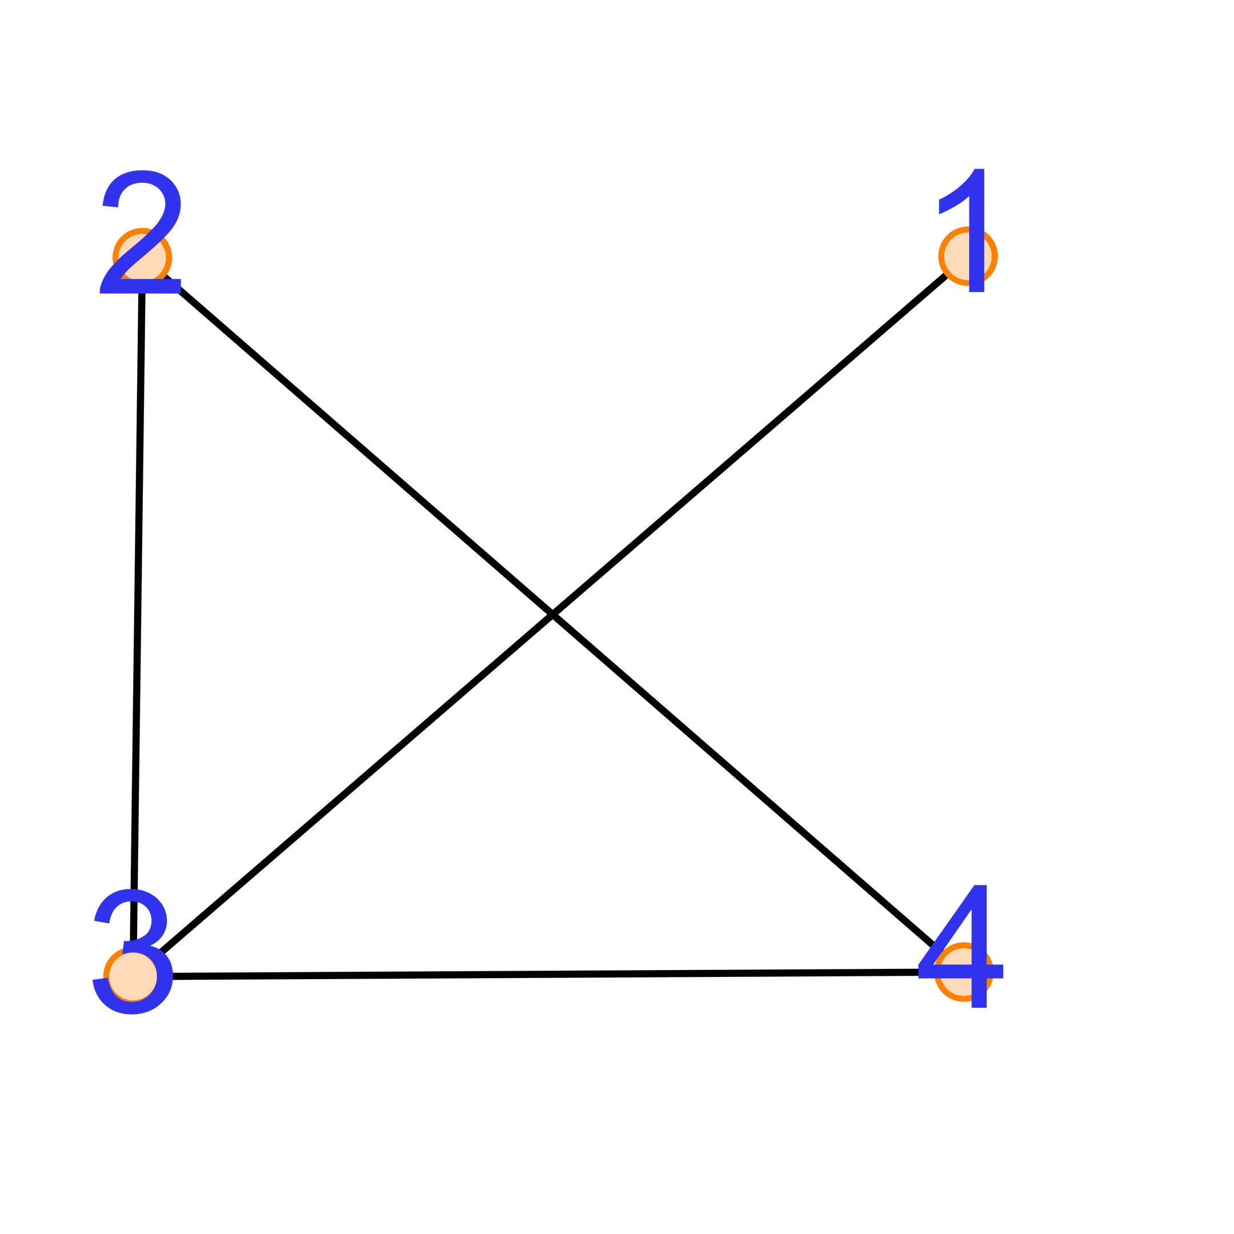*Closed triplets* = {(2,3,4), (3,4,2), (4,2,3)}

The triplets differ by the central vertex, i.e., the triplets (2,3,4) and (4,3,2) are the same triplet, however (4,2,3) and (2,3,4) are different triplets.  
*All triplets* = closed + open = closed + {(2,3,1), {1,3,4}}  
The global clustering coefficient for this graph is 3/5 (the ratio of closed triplets to all triplets).

It is easy to see that for every three closed triplets there is one triangle, so the number of closed triplets = 3 x (number of triangles).

The interpretation in the context of the students' analysis can be as follows. If you look at the graph above and think of it in terms of students, then for student 4 and student 1, student 3 is a common friend, but students 1 and 4 don’t know each other ([1,3,4] is an open triplet).

That is, we can interpret this metric as "reaching the potential of mutual friends", whatever that means. If this phrasing seems strange, we can say otherwise:

How close to reality is the statement *"a friend of my friend is my friend"* for this group of students.

Unlike the average network coefficient, the global coefficient will have about the same degree of smallness as the density, and this is due to the fact that the denominator of the global coefficient is this thing (the number of all triplets), which is more extreme than ~|V|2 (=|V|*[|V|-1]/2) in the case of density:

$\sum_{i}{\frac{k_{i}\left(k_{i}−1\right)}{2}}$, summation over all vertices; ki – degree of the ith vertex (number of edges connected to it)

This metric is noteworthy because (unlike density) it also takes into account the relative location of the edges.

### Average Shortest Distance

The average shortest distance for a given a graph is the average of the shortest paths between all the vertices of the graph.

The interpretation is as follows. The average shortest distance in the graph of students is the average number of handshakes through which students know each. If this formulation does not bring clarity (and especially if you have not heard about the theory of 6 handshakes) - watch this [video[9]](https://www.youtube.com/watch?v=mIEaD0BSlkw)!

The closer the value of this metric is to 1 (if it’s 1, then on average, everyone knows each other personally), the better students know each other. This is probably the most optimal metric, since it takes into account the location of the edges, and is also easy to understand, but it is still not ideal, at least because it does not report what the density, average network and global coefficients do.

## Oriental studies

Armed with the necessary theory, you can finally look at real graphs! The first educational program is Oriental Studies.

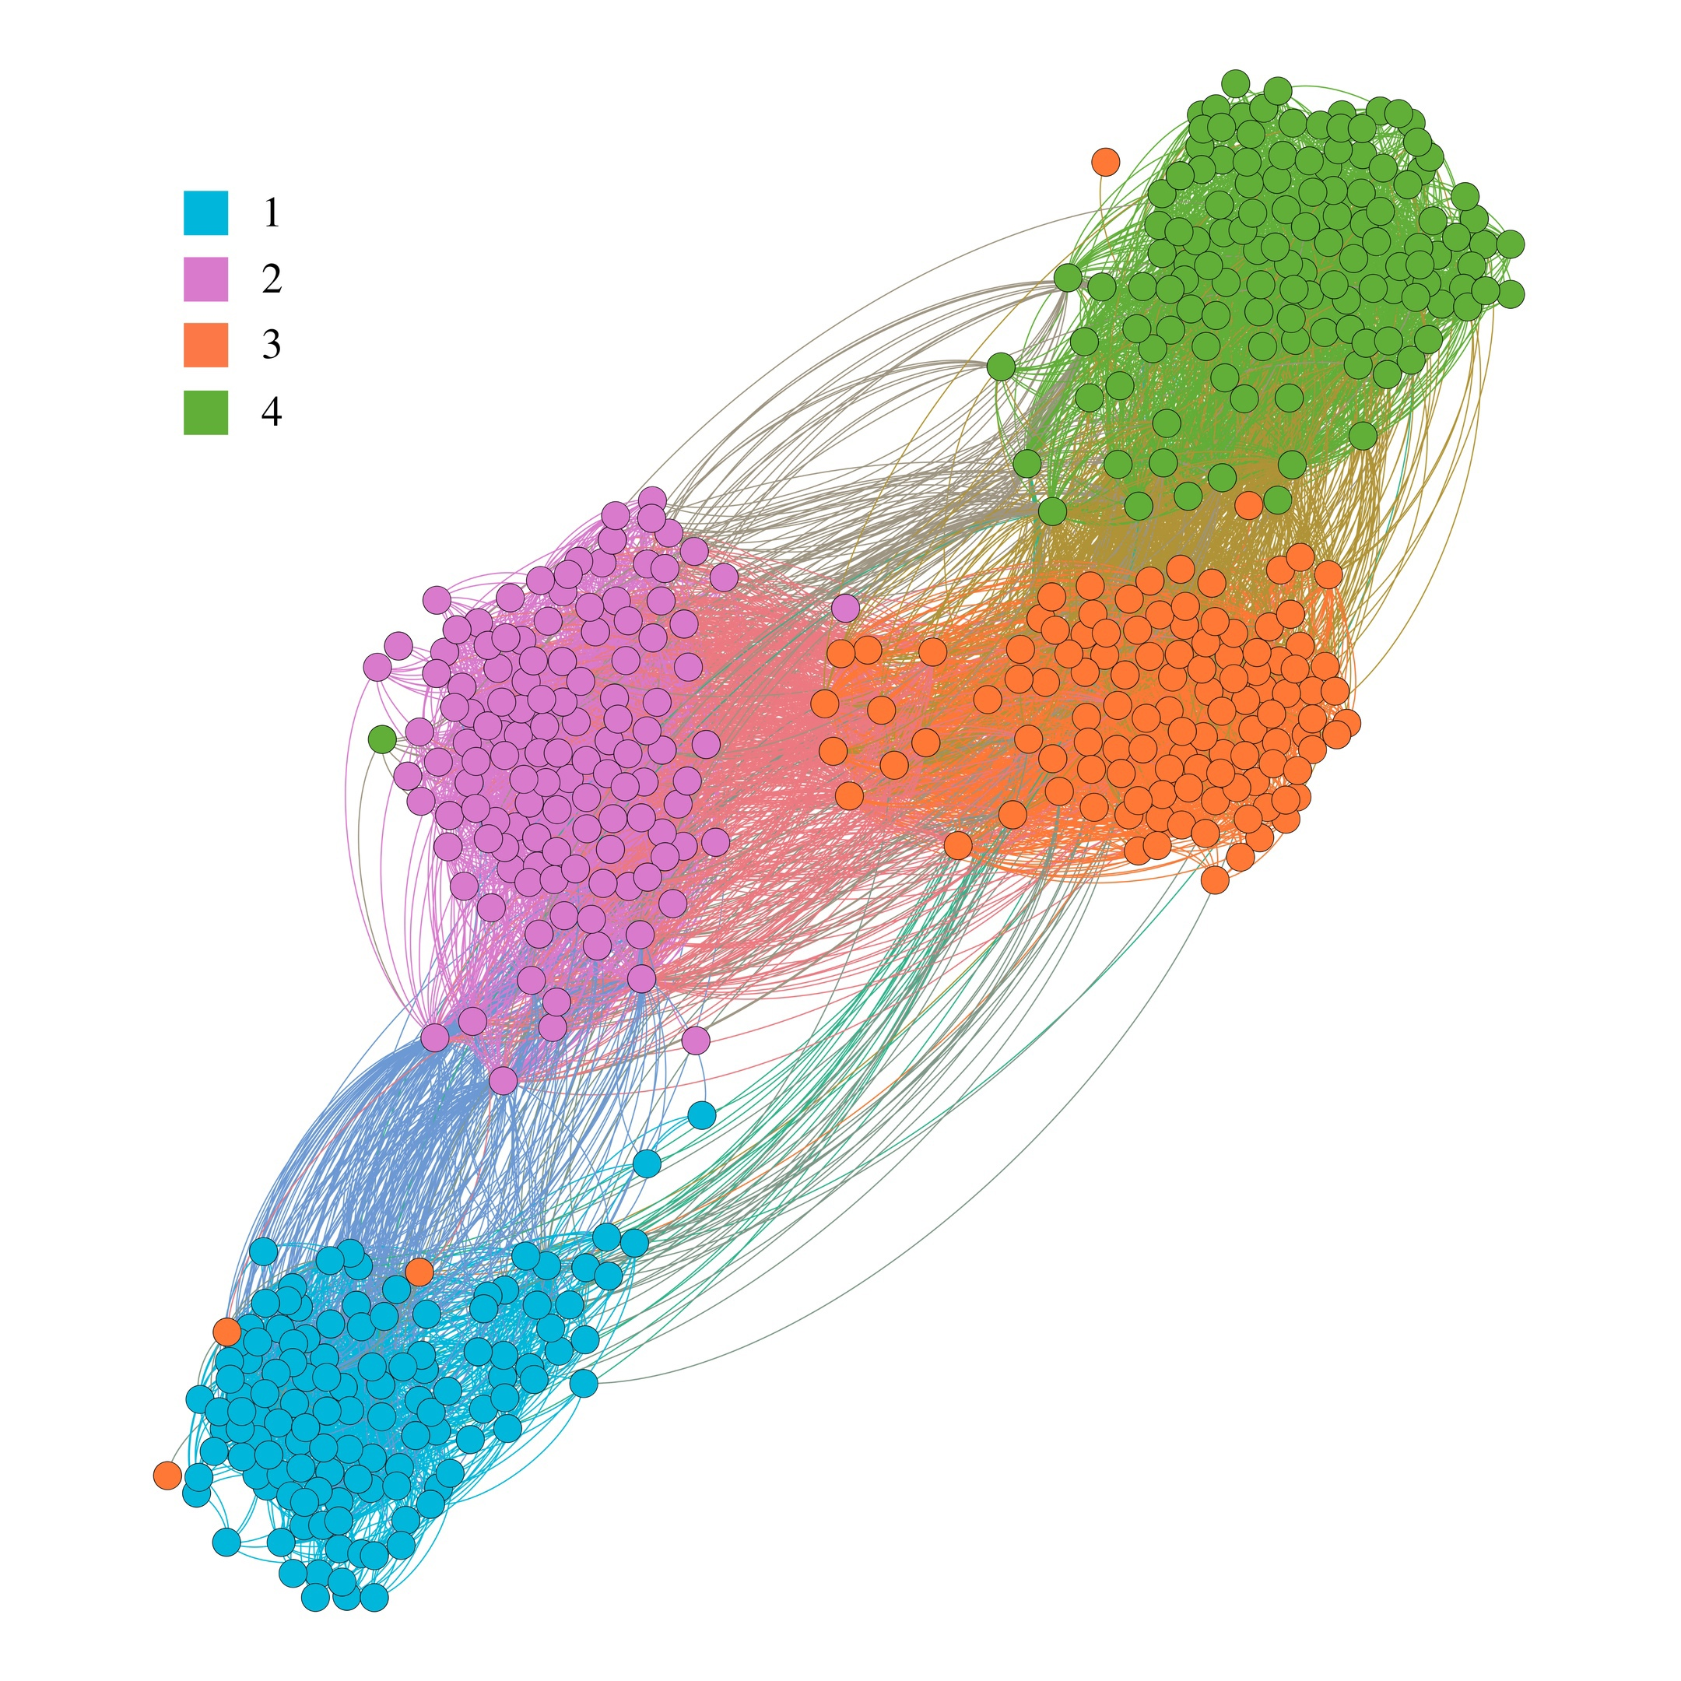

Picture 1. Oriental Studies. Different colors correspond to different years (from 1st to 4th)

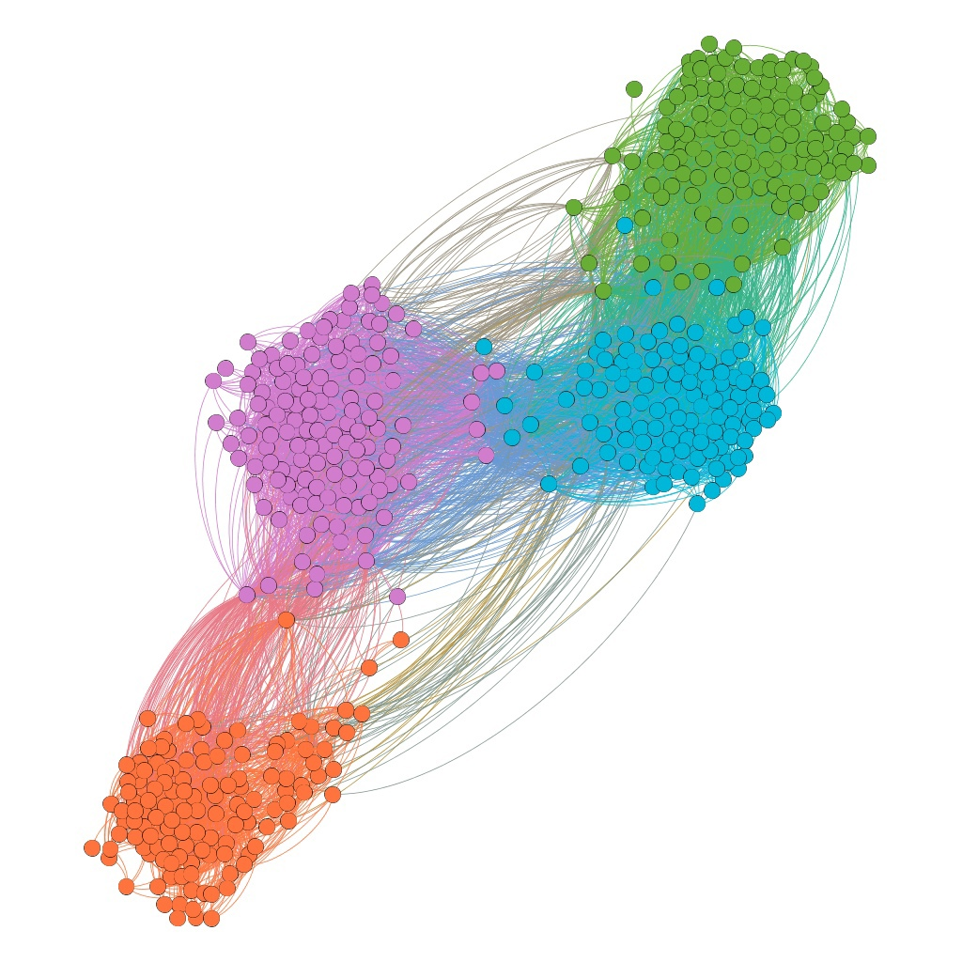

Picture 2. Oriental Studies. Different colors correspond to clustering as a result of applying ForceAtlas2

It may leap to the eye that some students are not in their own clusters (for example, in a first-year cluster, there are three students from a third-year cluster).

This can be either the result of an error when processing data and assigning a year to a student (again, this was not done manually for most students), or something else — for example, a student might have transferred from another program. However, there are very few such "anomalies", so you may close your eyes to this.

As mentioned in the section on layout, a graph can be drawn in more than one way, and I use layout which helps to maximize modularity of the whole graph (and reveal clusters based on the density of connections between students). So, it is not surprising that in the second picture, the color split represents the layout, because the modularity is the basis of the color split there.

However, the following is noteworthy: the layout, which does not take into account the known [for us] information about how students are assigned to years, actually gives us this info! If you compare the two images, you can see that the color split based on the year is almost the same as the split based on the modularity[10]. In other words, students are naturally grouped by their year[11], i.e. the connections within their year are stronger than the connections between different years, but there is an exception.

Pay attention to the vertices that are located between the clusters, i.e. not adjacent very tightly to both clusters (here it is best seen between the 2nd and 3rd years), and try to guess: who might these people be categorically? When we get to the graph where this is particularly evident, I will ask this question again, but for now I will leave it to you.

The faculties in this article are arranged alphabetically[12], and it just happens that Oriental Studies is one of those faculties that does not show obvious anomalies/something that would be worth a comment, except for what my question above touched on, so the situation here is "we see what we want to see".

This boring trend (we see just what we expect) will be the case for each educational program, and it may seem boring, since I am not comparing HSE students with students from other universities here, but the fact that students in the graph are located exactly in accordance with their years, and closely adjacent to each other within them, is still worth paying attention to (since this means, among other things, that the students at HSE are quite "tight-knit").

Nevertheless (and this can be seen already in the example of the graph of Oriental studies), students of different years are not equally densely located within their years, i.e. this relatively high internal density is not something that occurs by default, something that is formed naturally within a group of students of any year - and students of different years of different programs (we will see this later) are "close-knit" in different ways.

## Design

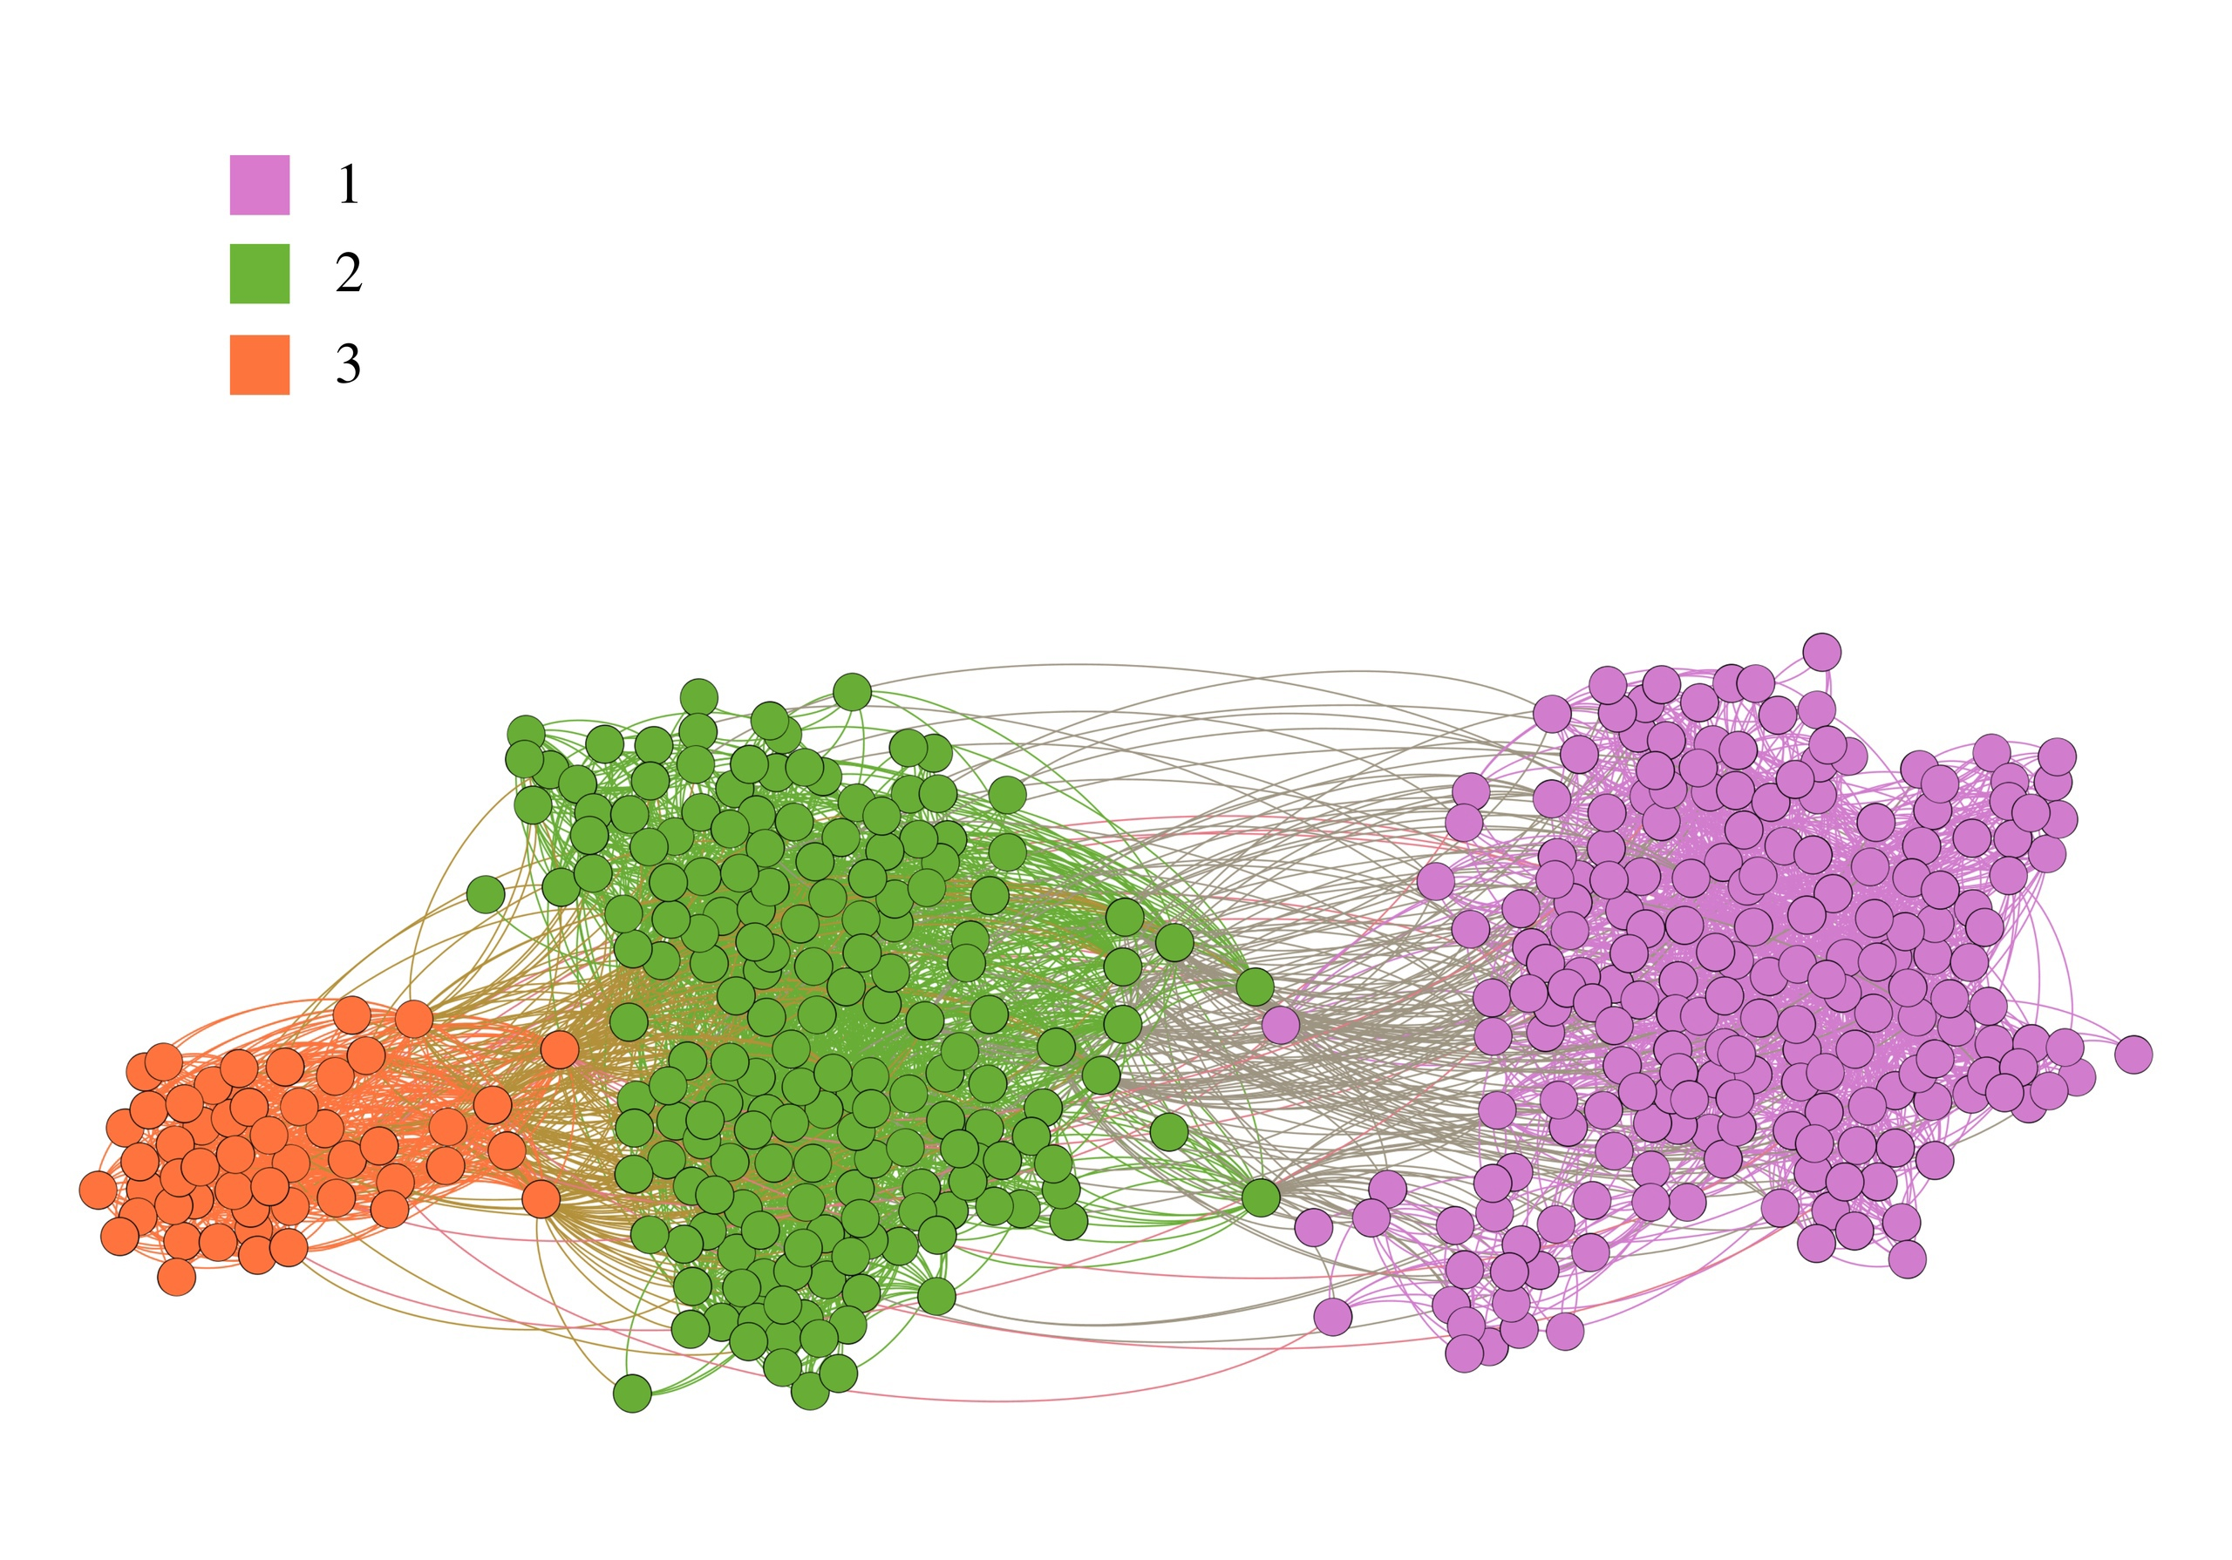

Picture 3. Design. Different colors correspond to different years (from 1st to 3rd)

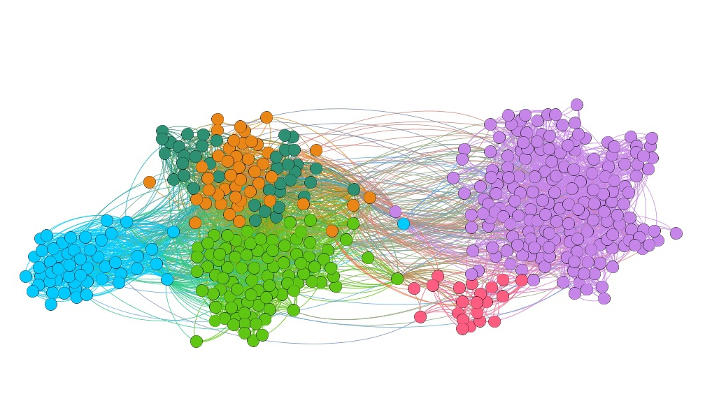

Picture 4. Design. Different colors correspond to clustering as a result of applying ForceAtlas2

Already with Design there is something to pay attention to!

**First**, and this is better seen in the second picture, there are subclusters inside the first and second years. So, in the case of a purple cluster, the crimson group is most likely an academic group. It should be noted in advance that within this article I will not check whether the clusters within the years obtained "on the basis of modularity" are actual academic groups, except for 3rd year students of Management, since I studied with them for a year before taking a gap year.

The illustration of the graph of the 1st year students of Design (on the left) is noteworthy, since it clearly identifies 10 clusters (I wouldn’t 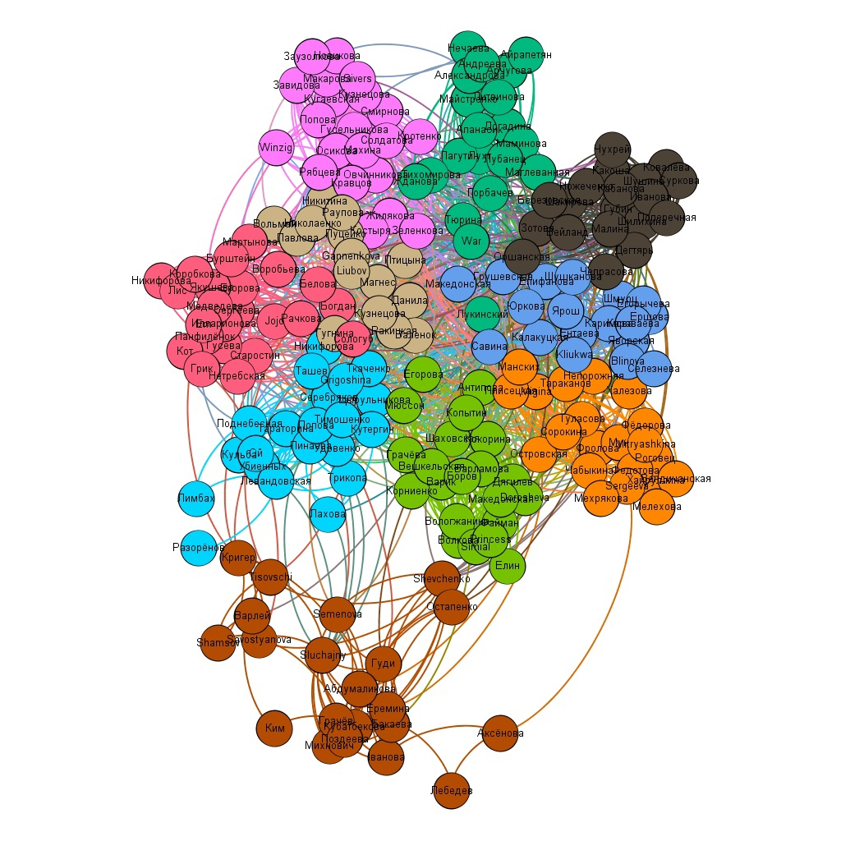trust the dark beige one much, so rather 9), which can potentially be real study groups.

If these clusters are study groups (more or less), then, on the one hand, we can say that students within the groups are "close-knit" enough to form such clusters, but not connected enough with other groups to form larger clusters (to be a single whole as a year or at least as elements of a year). This is not as bad as it sounds, and it would be more surprising if all of the roughly 200 first-year Design students were friends with each other (remember how graph density is calculated).

**Second**, the second year is divided in half almost equally, with one of its halves again divided approximately equally. While the latter division can be interpreted as a possible division into academic groups (there are not many students in the orange and swamp clusters), the division into two large parts is something different.

I have heard about the division of design students by professional profiles, and if this is it, then the clusters we see can be interpreted as follows: when current third-year students just entered the University, this division may not have existed, but for current first-year students, it either has not yet happened, or again, it’s something else (do not forget that COVID-19 contributed to student interactions – thus it might have contributed to such a division of first-year design students).

However, when considering the sophomores of Design separately from the graph of all the students studying in Design, the situation is different:

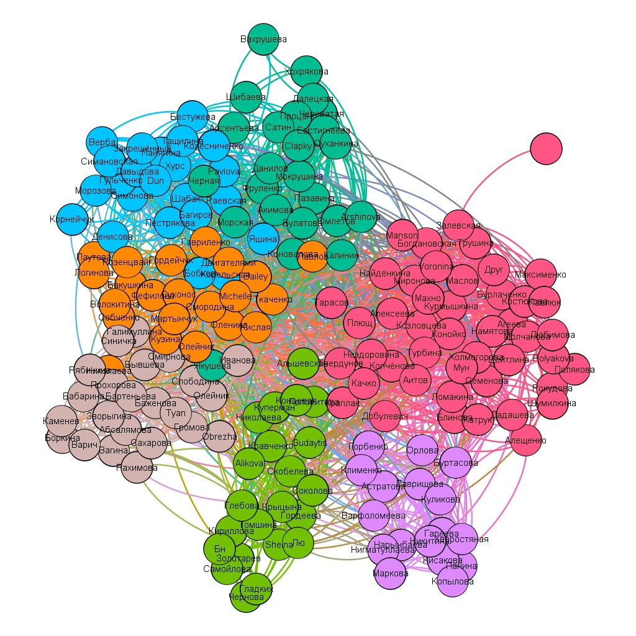

And such a change in clusters is normal, because now we are considering the second year outside the context of the entire educational program. We can understand this, roughly speaking, as these students tend to form groups according to what makes them similar. If you gather all the students of one educational program and ask them to from groups, then the most logical option is to first break up into years (this we have seen clearly so far when we considered the educational program graphs as a whole), and then into study groups.

Still, we can trace a slice in the middle (separating the green, crimson, and purple clusters from the rest) that was still visible on the graph of the entire program, so this may be something more than a coincidence or the influence of the program context.

## History

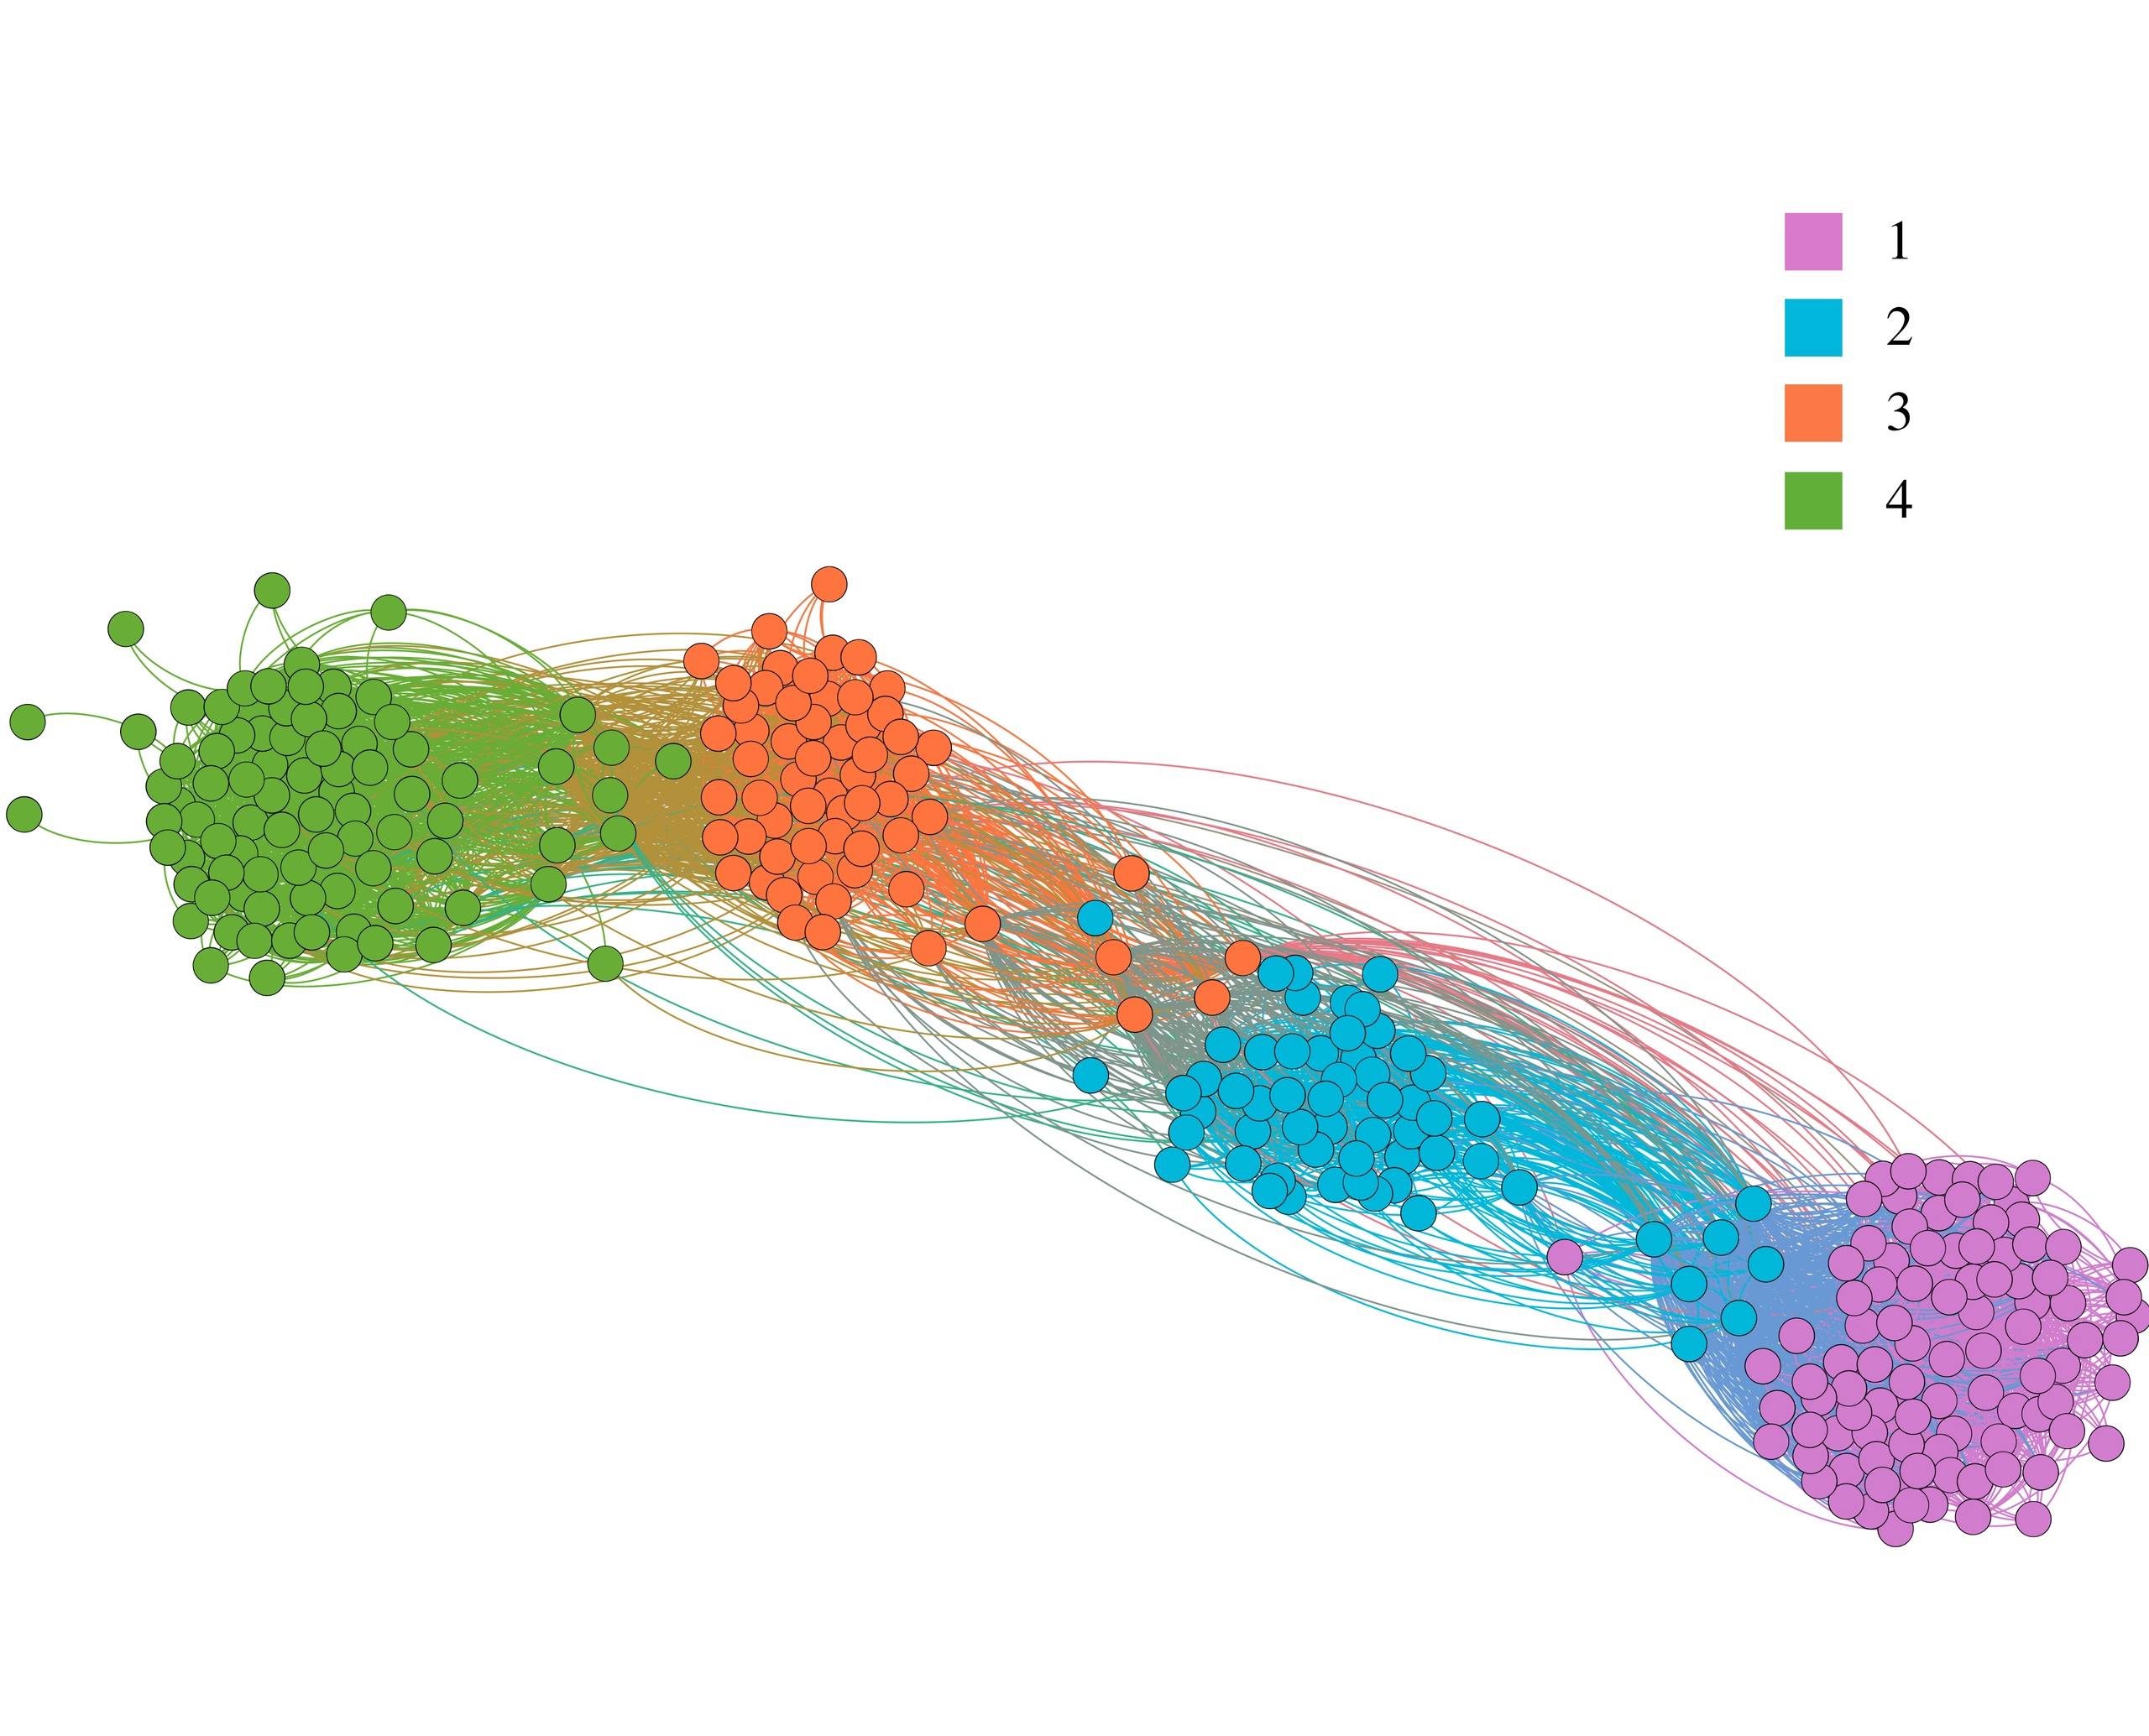

Picture 5. History. Different colors correspond to different years (from 1st to 4th)

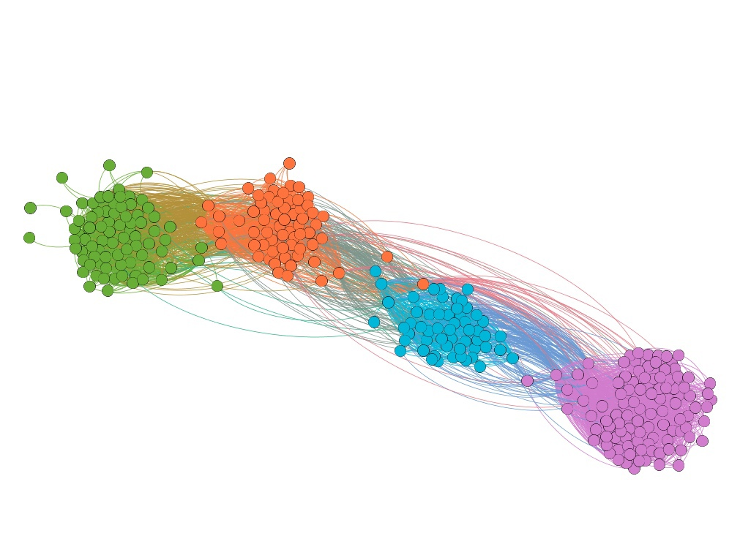

Picture 6. History. Different colors correspond to clustering as a result of applying ForceAtlas2

Remember my question about the people located between **clusters** of years? If you don't have an answer yet, this is the last attempt; here it is especially visible between a group of people “moving away from” the 4th cluster to the 3rd one, as well as from the 2nd to the 1st (very close to the first).

Answer: these are curators. From the perspective of layouts, these are people who do not clearly belong to the same program, and when clustering in order to maximize modularity, these people often fall into the cluster of their first-year students.

This is especially evident in the second picture for the 2nd year curators there: they are falsely assigned to their freshmen, and this may mean (and does mean, see the visualization below) that they are more involved in interacting with them than with their own year (even after spending a year with their fellow students).

You can find the curators of the first year yourself in the first picture (on the left) after looking at the second one (just below): I copied the 7 people from the cluster of sophomores closest to the cluster of freshmen (see the graph of the entire "History" program above) and laid them out using 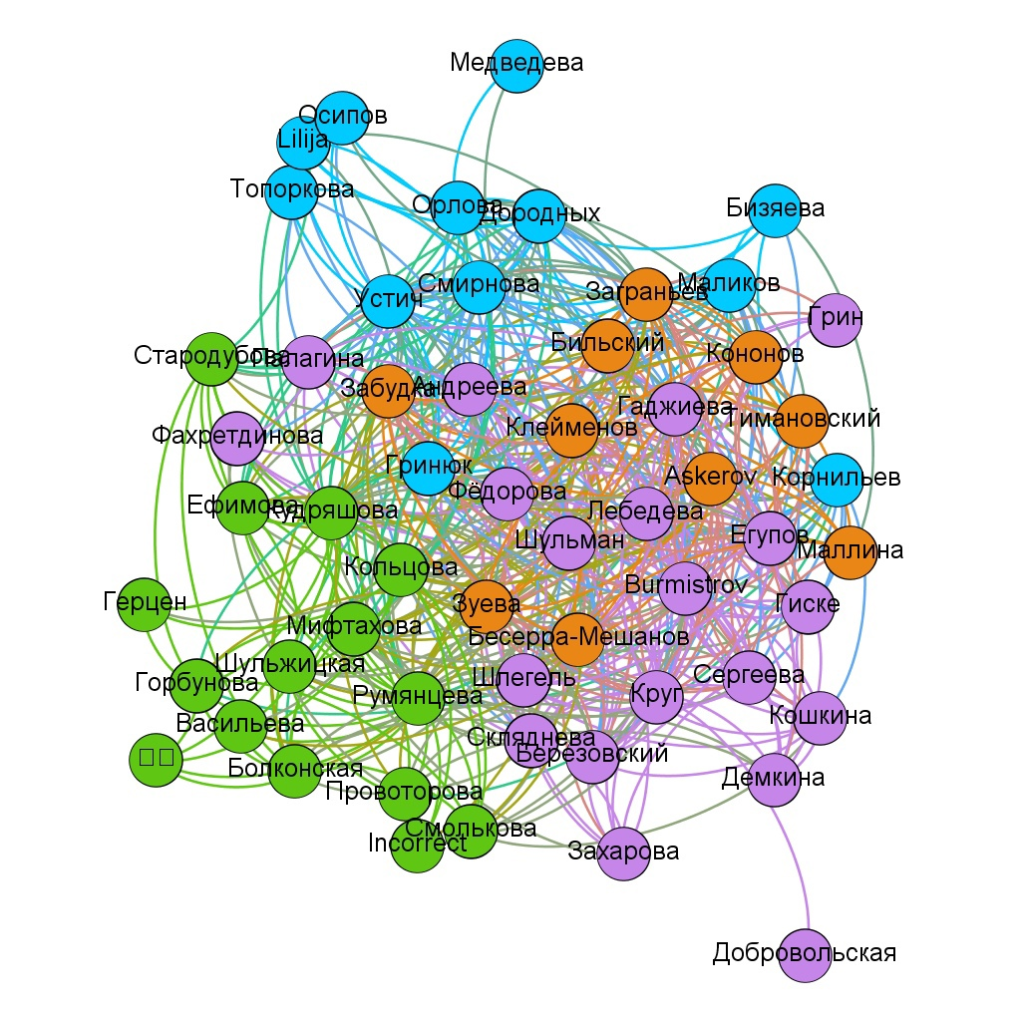the ForceAtlas2 mentioned at the beginning of the article.

As you can see in the second picture here (on the right), 6 people out of 7 are almost in the center of the cluster of the 1st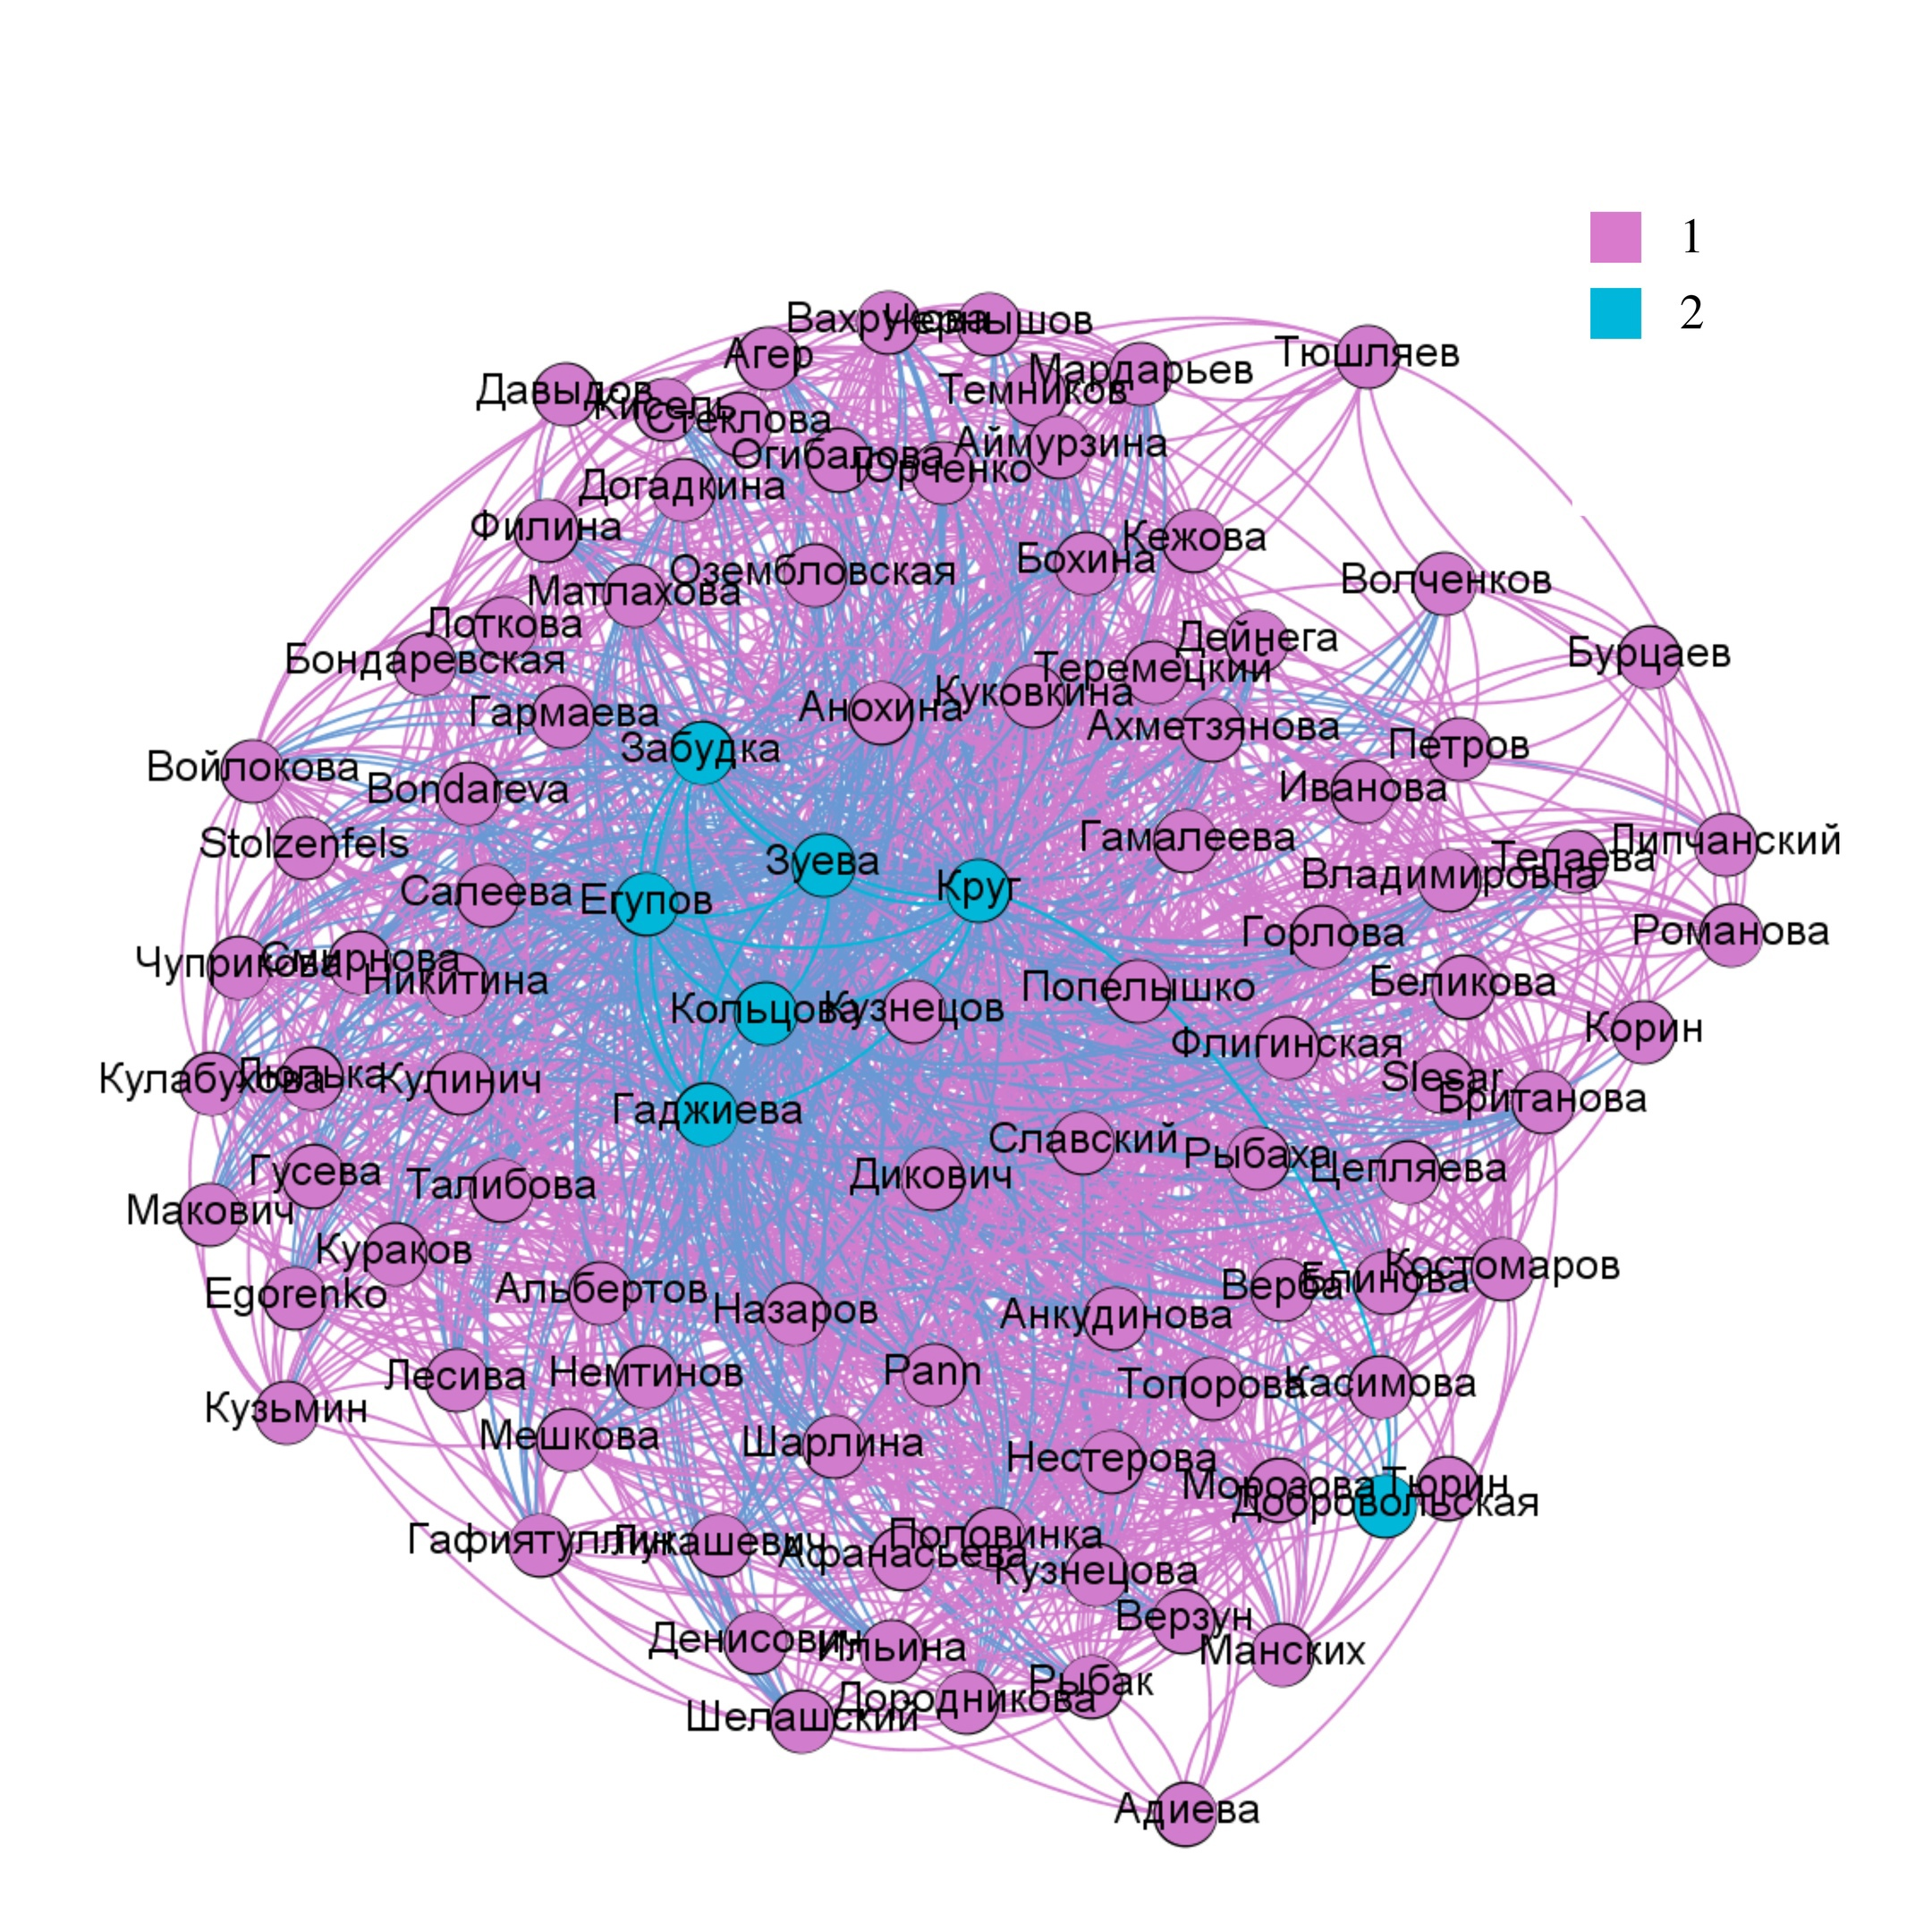 year, which is expected from the curators, who in theory "should know" (have friends on VK) most, if not all, of their first-year students.

This, however, should not be misinterpreted as "if after application of a clustering algorithm that maximizes the modularity of the given graph (hereinafter for short — ForceAtlas2), the curators remain in the cluster of their year, they are ‘bad’ curators." For example, here it may be that the curators "know" almost all of their freshmen, but there are more of them in absolute numbers than sophomores (there are more freshmen than sophomores).

I'll return to this when we start discussing the "Management" program.

## Logistics

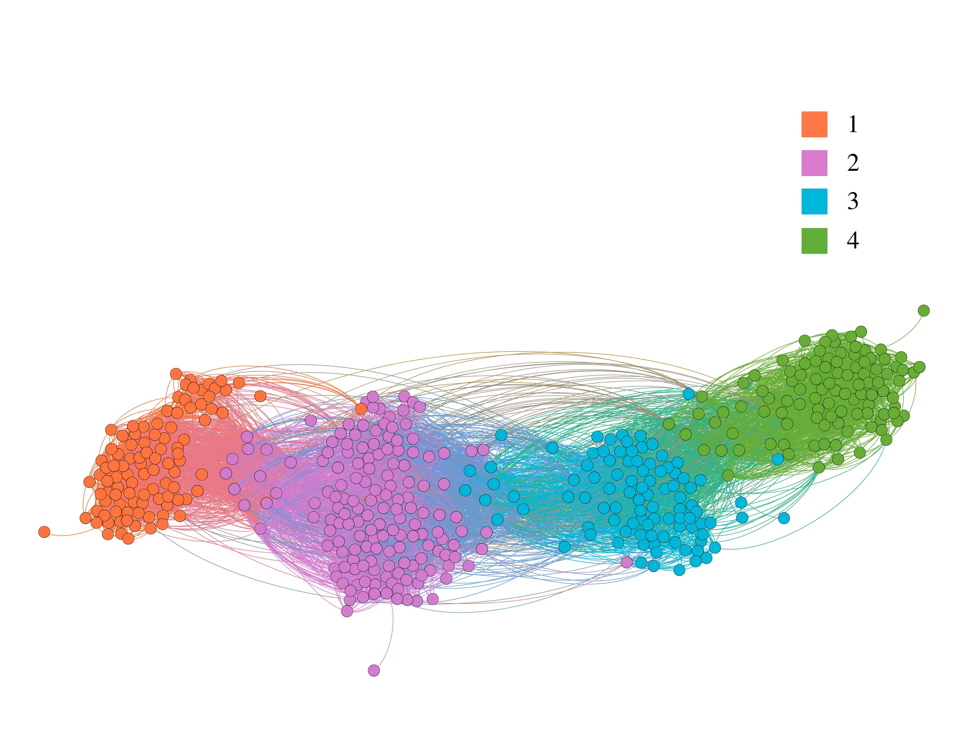

Picture 7. Logistics. Different colors correspond to different years (from 1st to 4th)

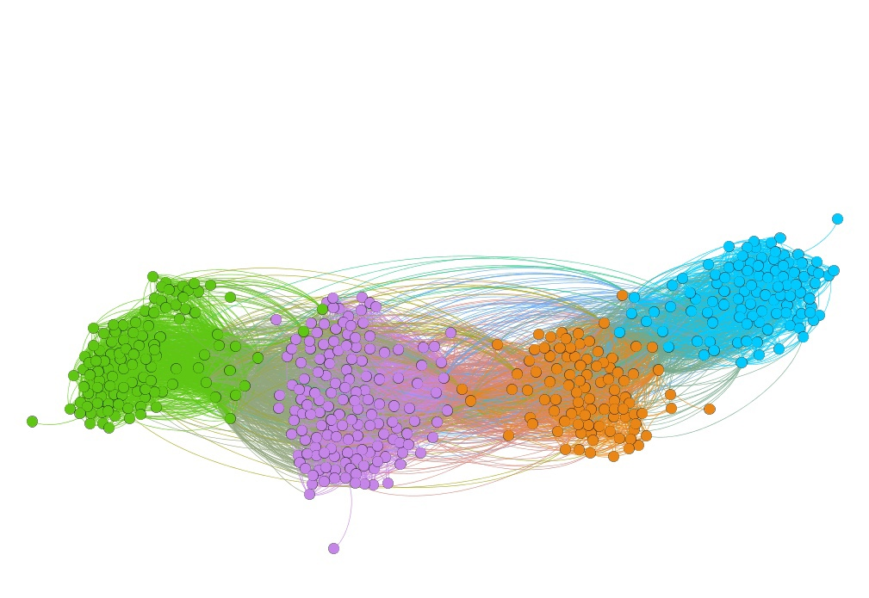

Picture 8. Logistics. Different colors correspond to clustering as a result of applying ForceAtlas2

As for “Logistics” in general, we more or less see what we want to see: as always (so far, except for “Design”), a good split into 4 “clusters-years” (2nd picture), which generally reflects the reality (1st picture).

Curators of current freshmen here are again more tightly connected with their first-year students than in the case of the 2nd and 3rd-year curators (again, I'll comment on this in the next section).

In the picture on the left (freshmen)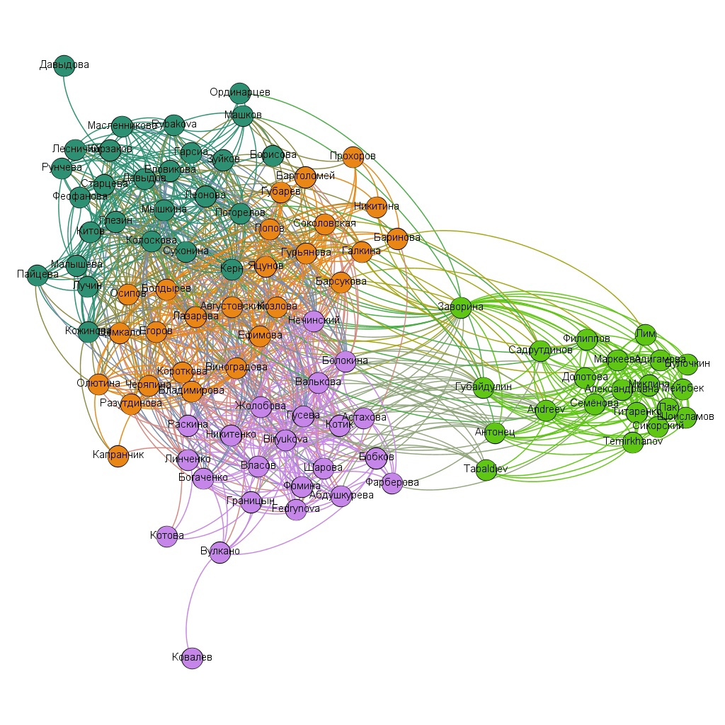, a group of students (the green cluster) leaps to the eye, which was located distinctly from the first-year students on the graph of all the students of logistics, so these students are indeed relatively distanced for some reason.

However, in the picture on the right (sophomores), we do not see the "cap" that was discussed above (see the 3rd picture below). People from the "cap" got into the light and dark green clusters, which do not lie separately from all the others as a whole. This means that, probably, this "cap" could appear just as a result of the “pulling” of parts of the cluster of the 2nd year students by, for example, clusters of the 1st and/or 3rd years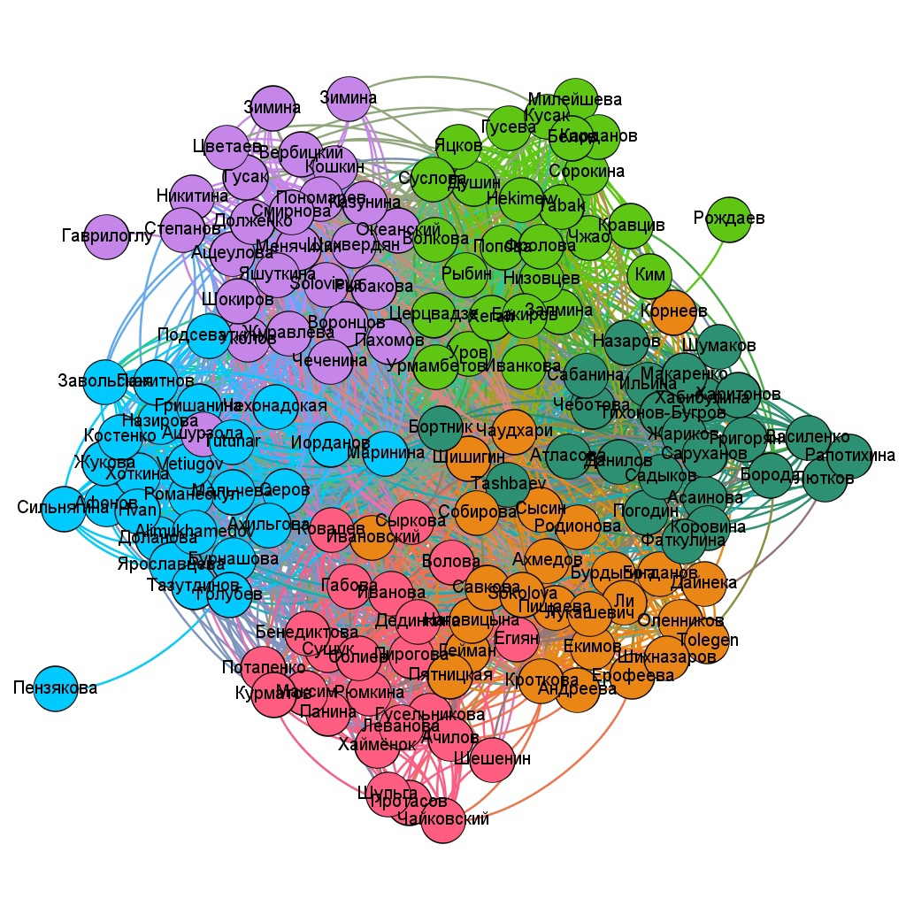.

## Management

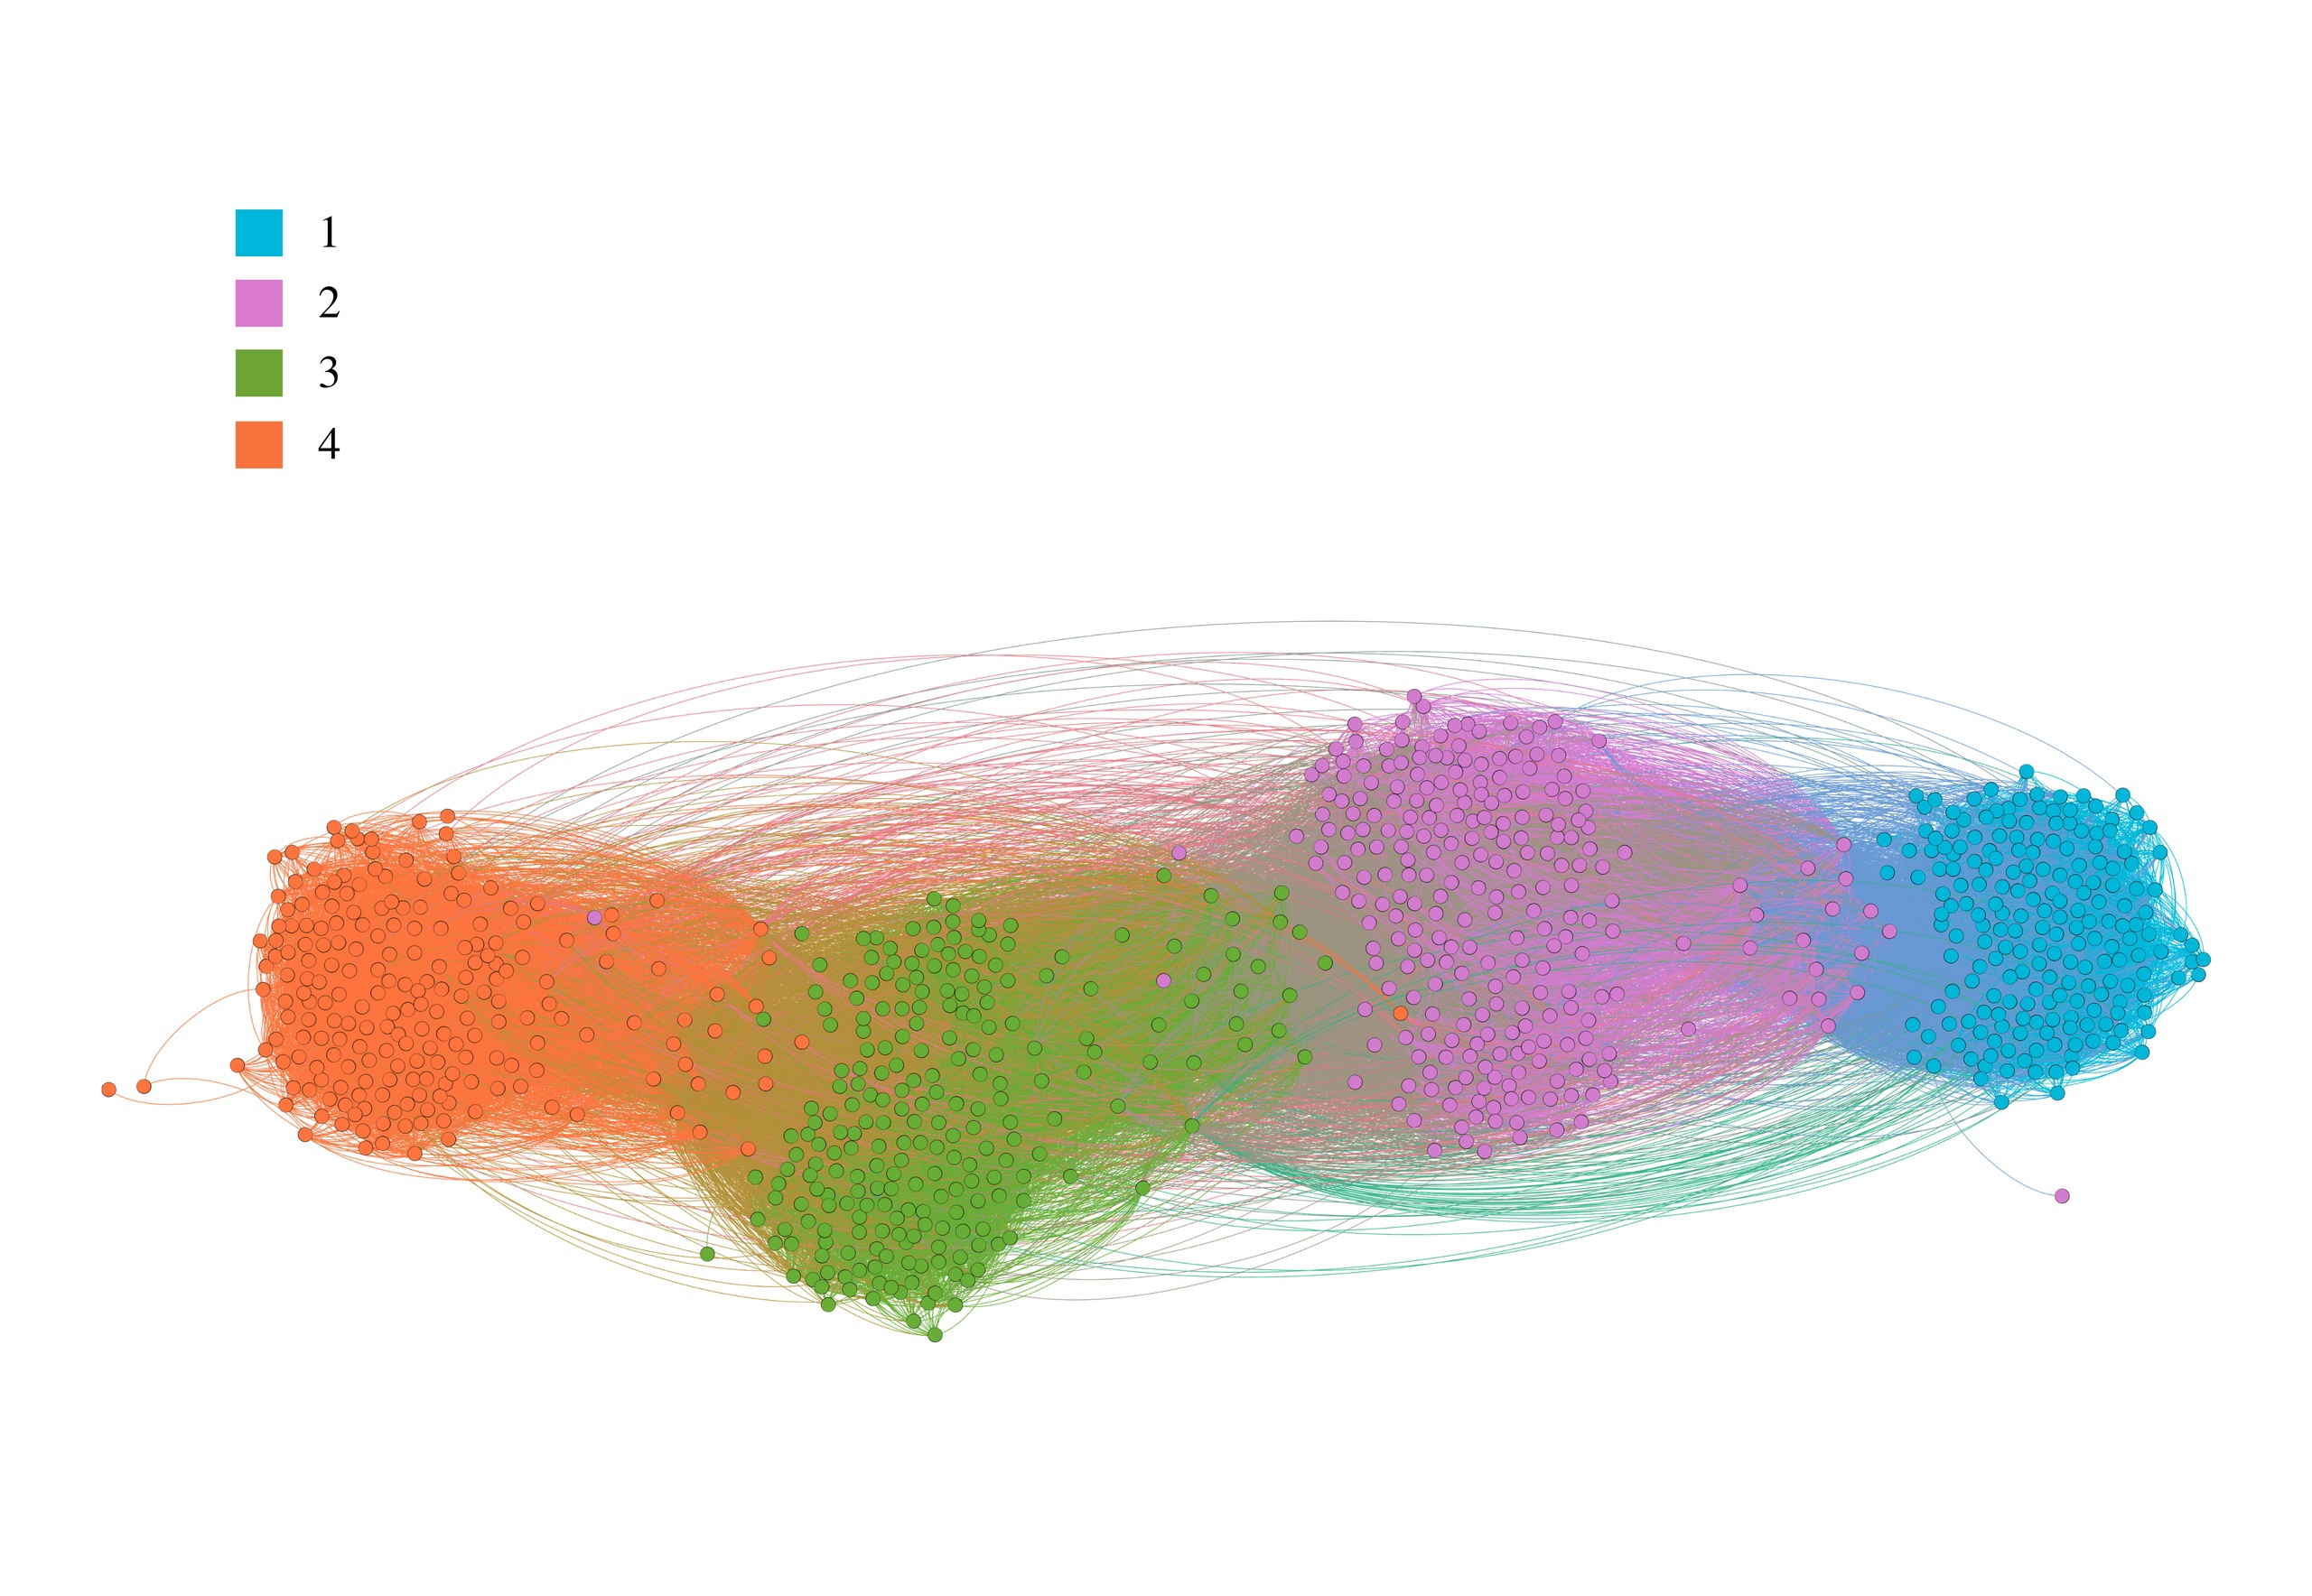

Picture 9. Management. Different colors correspond to different years (from 1st to 4th)

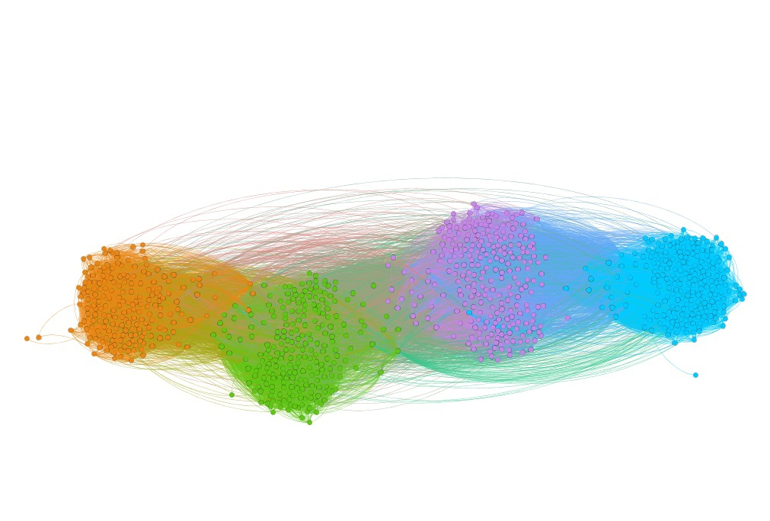

Picture 10. Management. Different colors correspond to clustering as a result of applying ForceAtlas2

Management is one of those programs where curators are particularly evidently out of their cluster (Picture 1) and often (when divided into clusters based on modularity) more likely to be in the cluster of their first-year students (Picture 2).

It is worthwhile here that the curators of the current first year are again (as was the case with the History graph) very close to their first-year students, but in the case of Management, the assumption about the number of students does not work: sophomores studying management comprise about 250 people, and freshmen— about 200. So it's just that the curators do not need to know all the people from their year, but now it is important to know all their freshmen, that’s why the latter pull their curators with more force than own classmates of these curators do.

A little bit about the 3rd year students, because I know most of them personally:

What is interesting in the picture on the left is that when mixing the 3rd-year cluster and the 4th-year students which are closest to it, not only the curators are in the center of the 3rd-year cluster (but also several people who are well connected with the 3rd-year students; what is their motivation — I do not know, so I leave this information as it is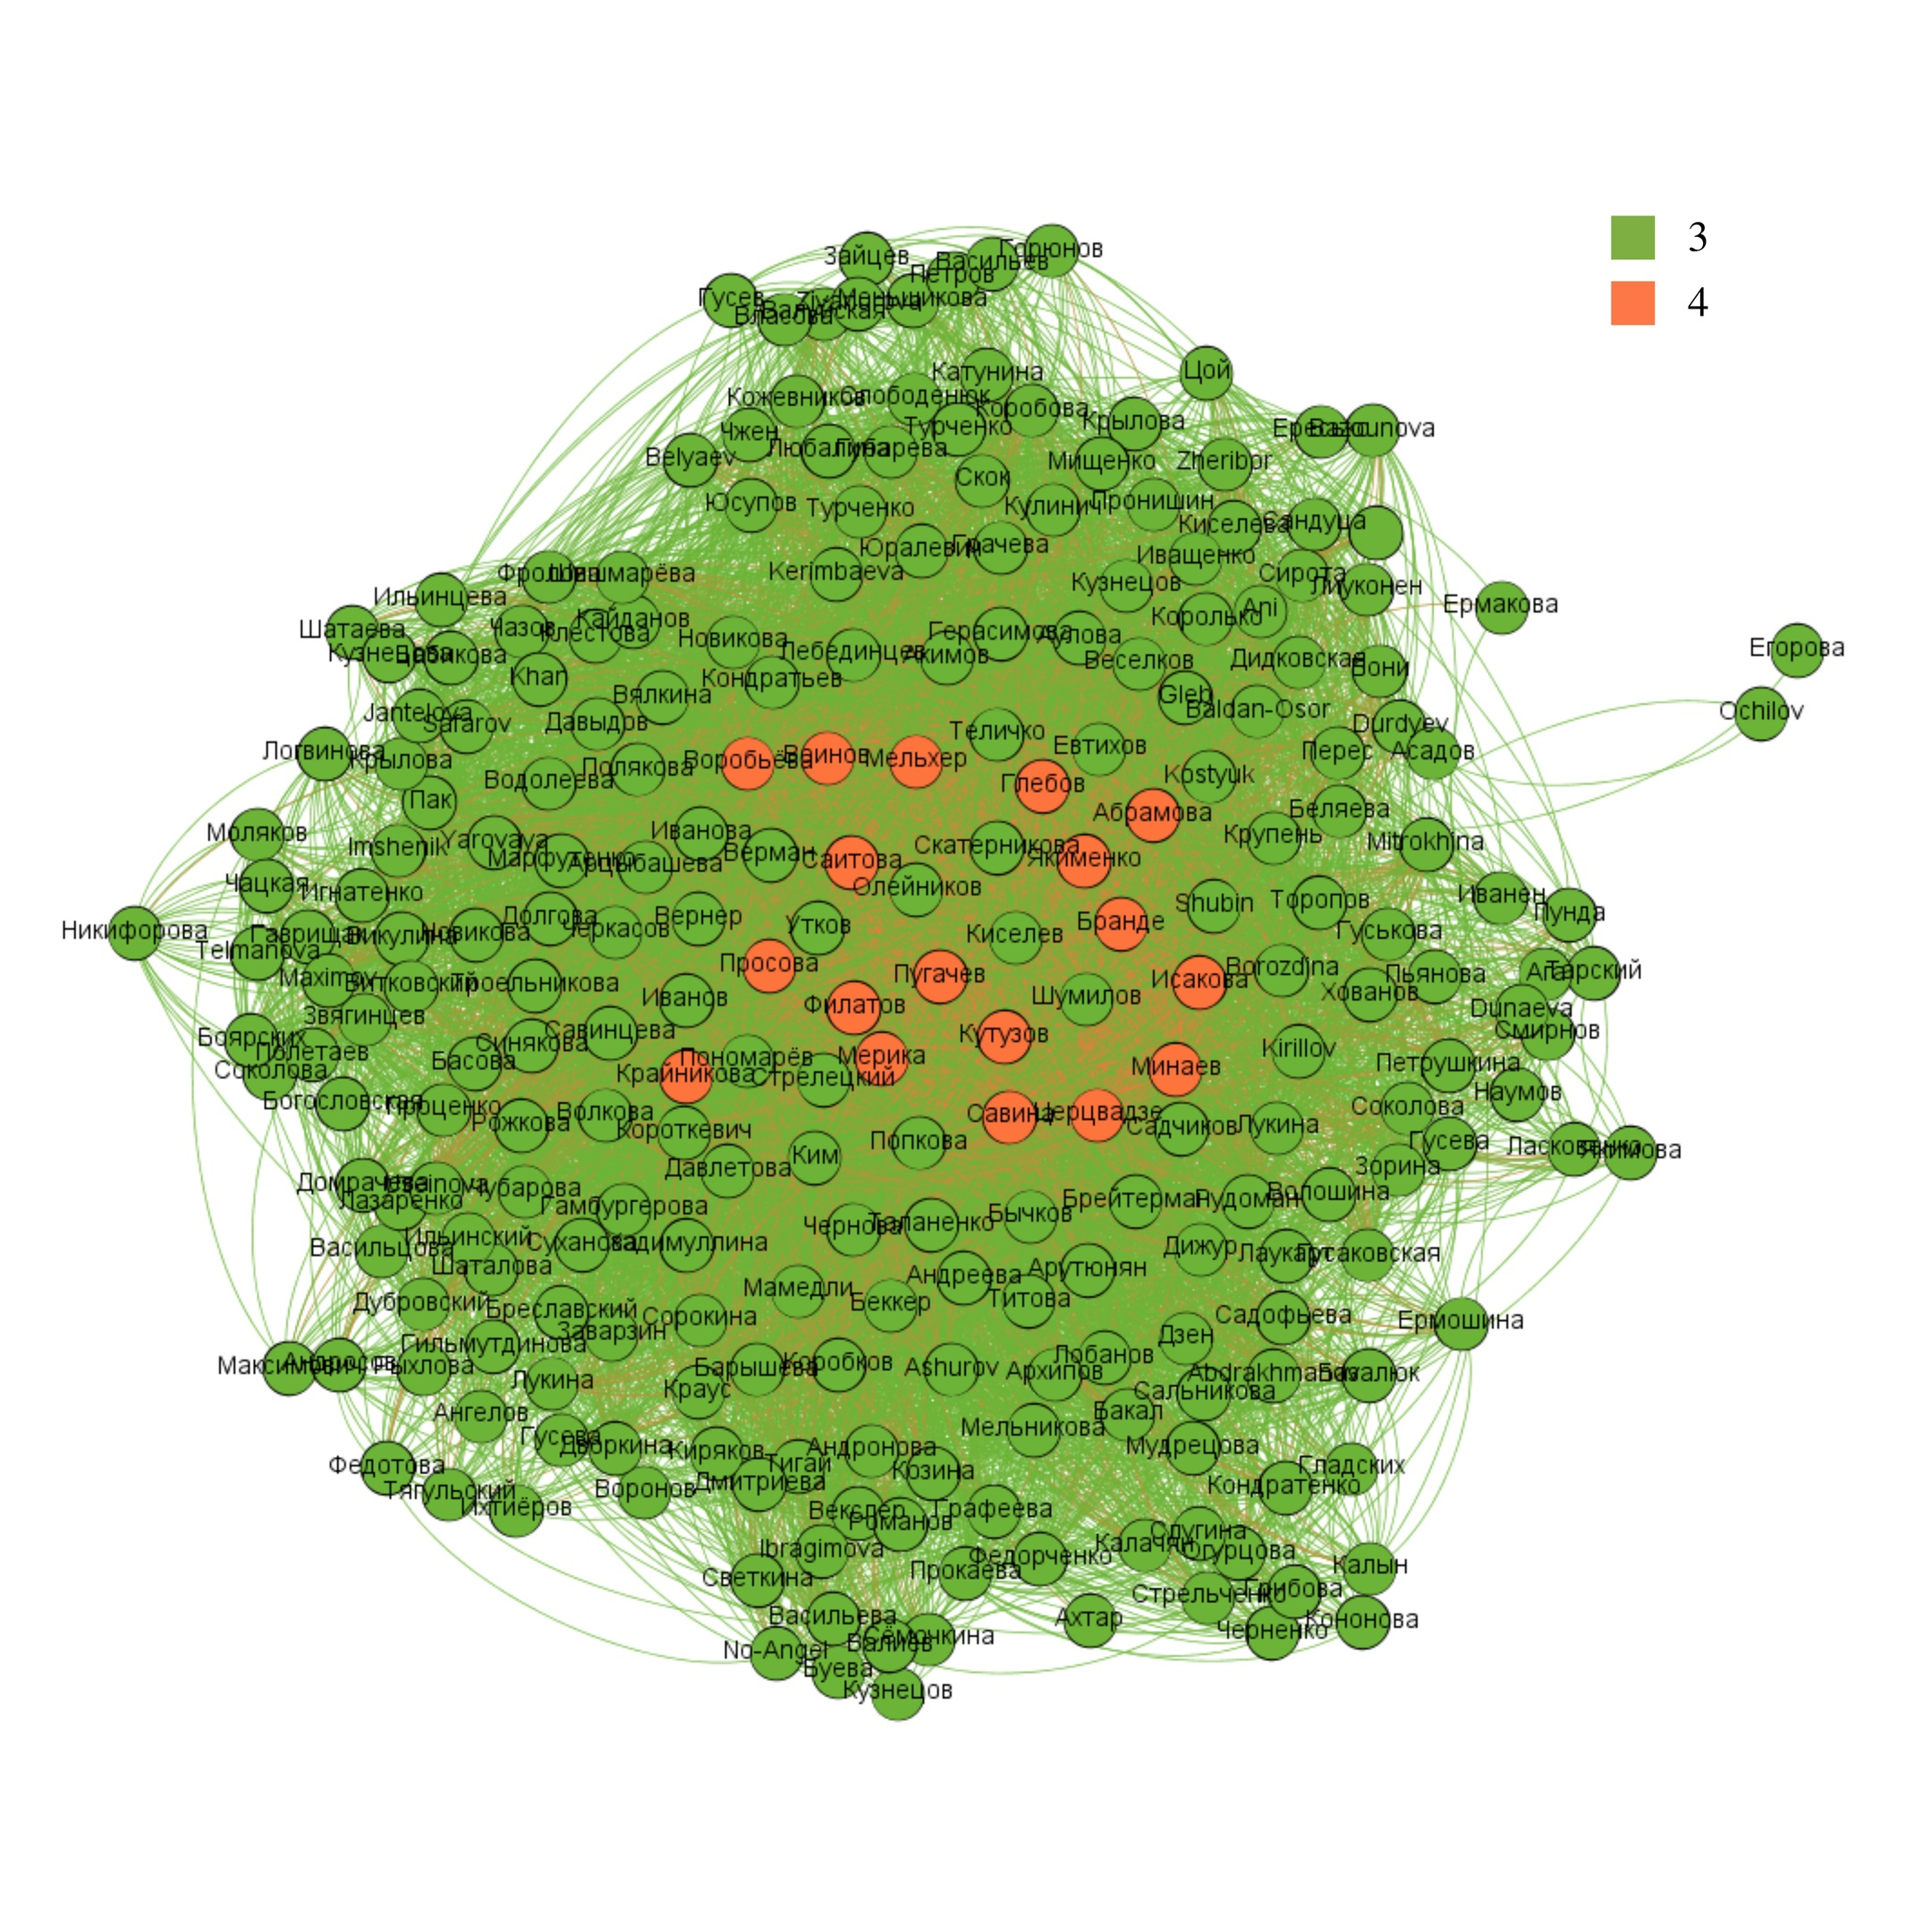).

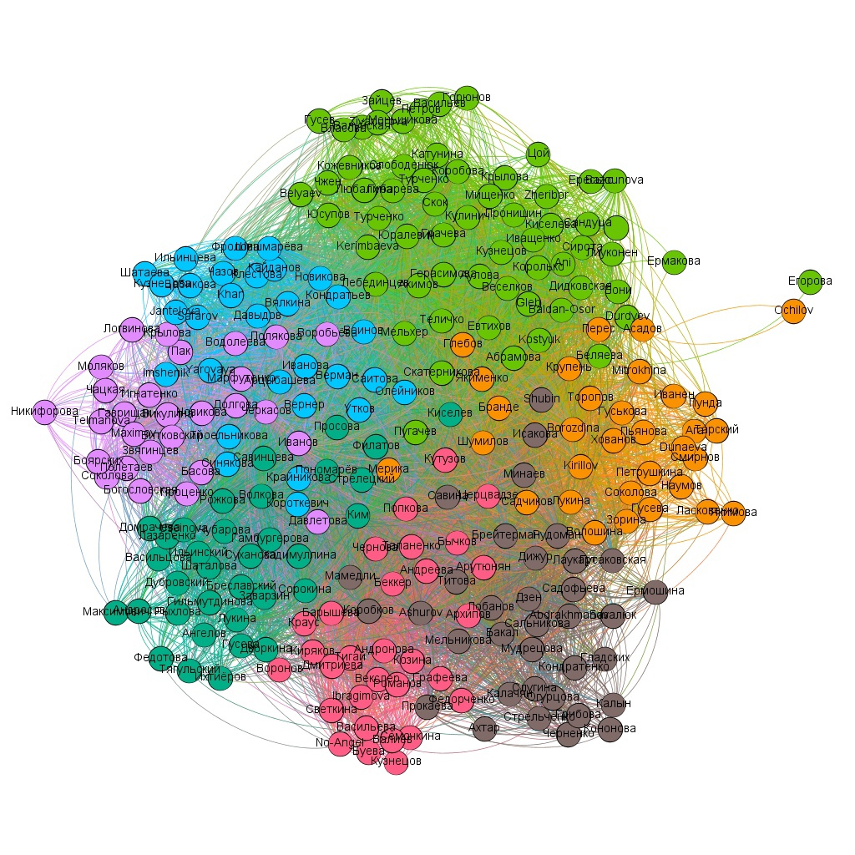

Also, different clusters in the picture on the left correspond quite accurately to how the students are actually divided into study groups, except for one cluster-light green, these are two English groups (in Management in the first year, we were divided into Russian and English groups, and most of our classes were held with different teachers).  
  
Almost all the curators (most of the orange vertices in the first picture) were placed in the clusters of the study groups that were actually assigned to them (picture 2).

Picture 11. Management. 3rd year students and the 4th year students which are most closely located to the cluster of the former. Different colors correspond to clustering as a result of applying ForceAtlas2

And finally, this is what the 3rd-year of Management looks like without the 4th-year students:

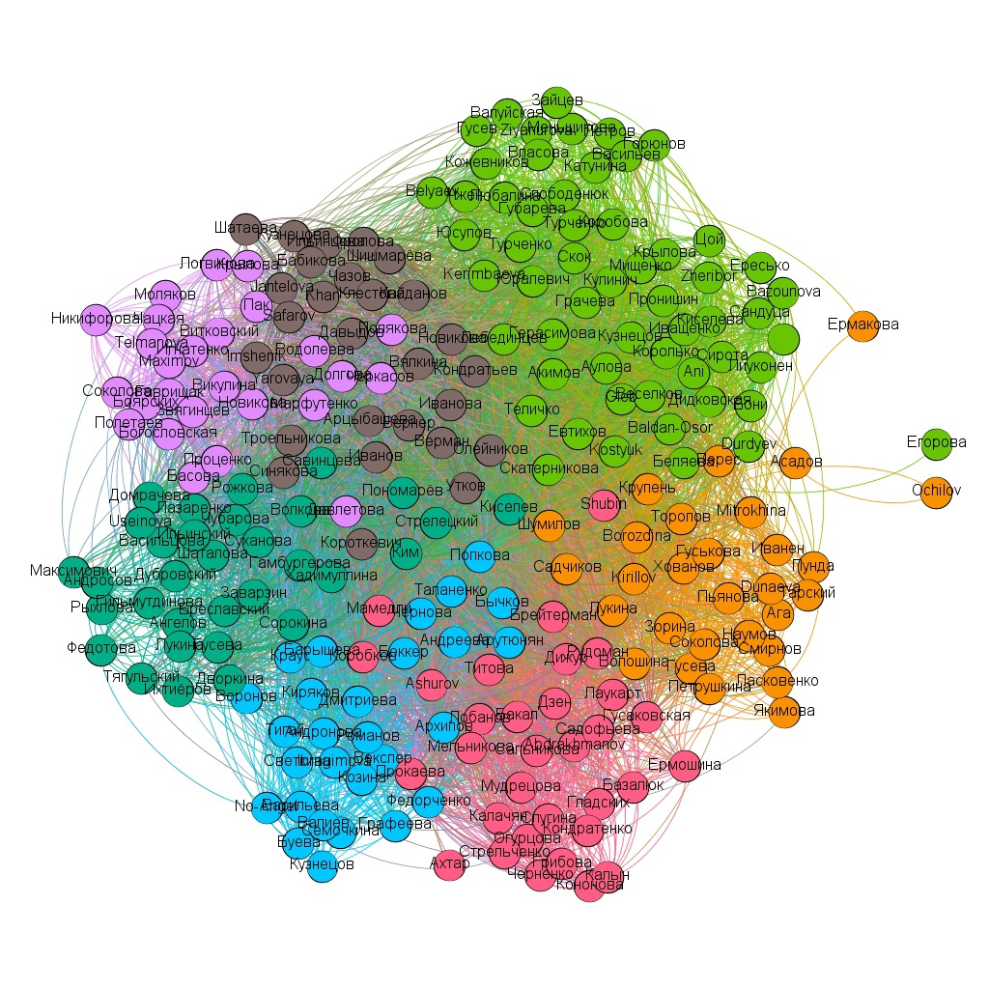

**Political Science**

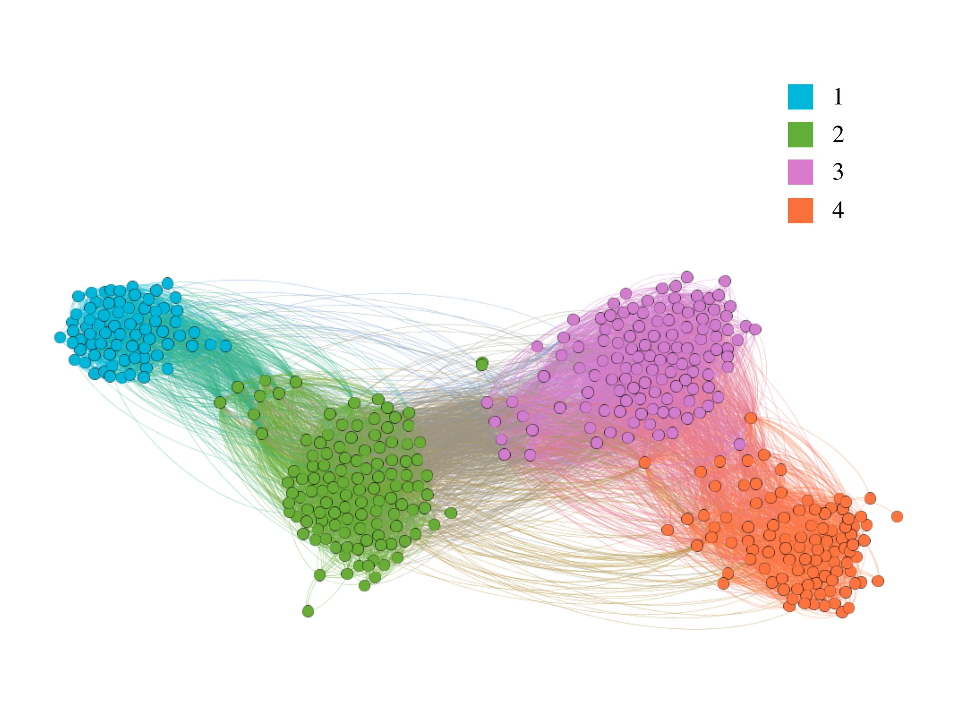

Picture 12. Political Science. Different colors correspond to different years (from 1st to 4th)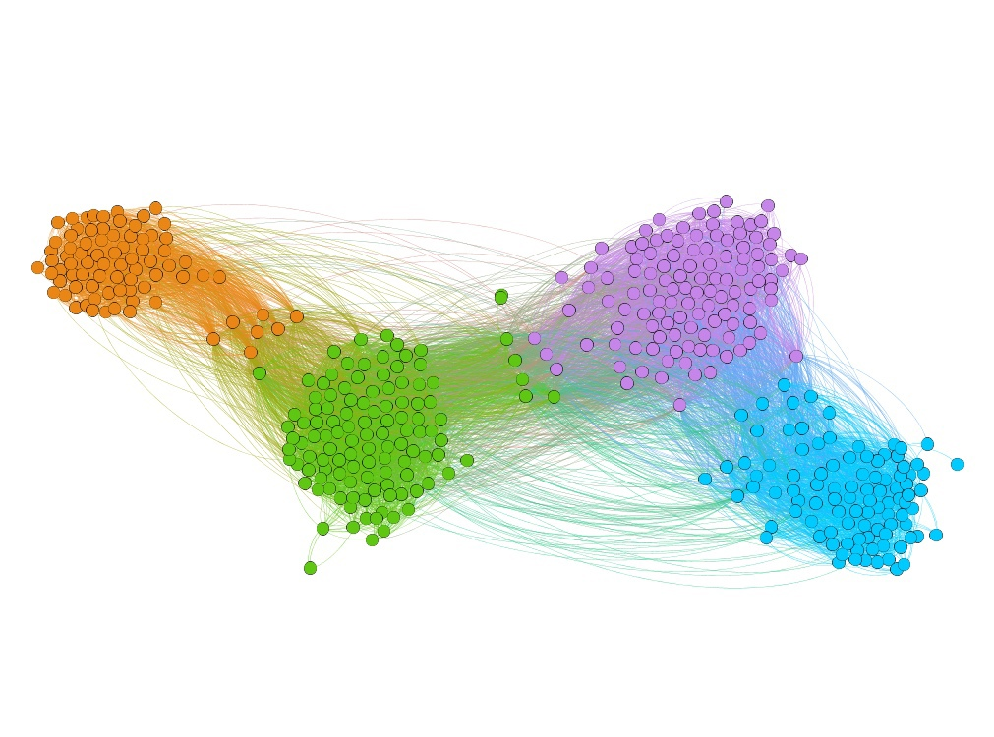

Picture 13. Political Science. Different colors correspond to clustering as a result of applying ForceAtlas2

There’s no apparent anomaly in the case of this educational program that would be visible on the basis of visualization. Clusters of students of different years seem relatively dense within themselves, except maybe the fourth one.

The following programs (Sociology, MAPS, Philology) also do not show anything unusual that could be noticed on the visualization: fairly dense clusters of years within themselves, good indicators of modularity in the graph as a whole (links within years are quite strong relative to links between them).

## Sociology

## 

Picture 14. Sociology. Different colors correspond to different years (from 1st to 4th)

## 

Picture 15. Sociology. Different colors correspond to clustering as a result of applying ForceAtlas2

## MAPS

## 

Picture 16. *MAPS*. Different colors correspond to different years (from 1st to 4th)

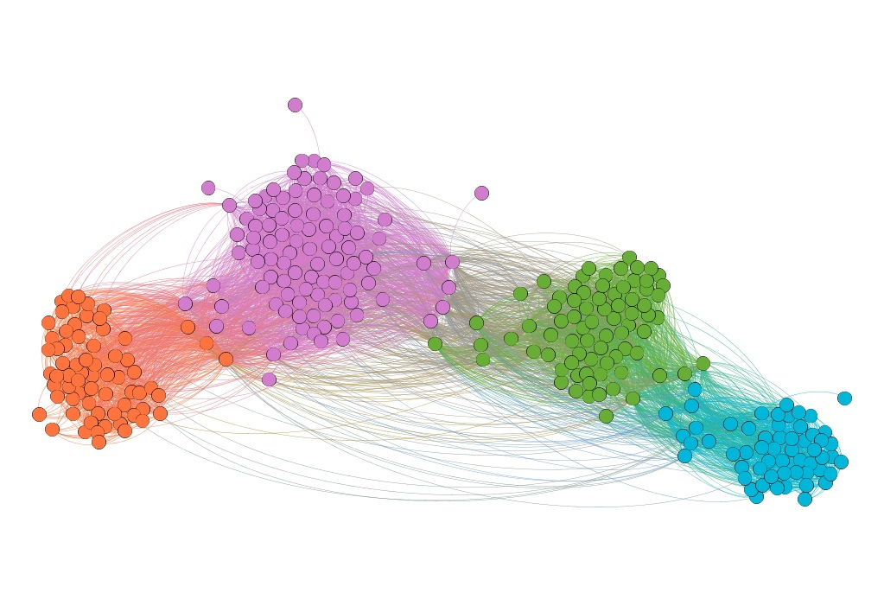

Picture 17. *MAPS*. Different colors correspond to clustering as a result of applying ForceAtlas2

## Philology

## 

Picture *18*. *Philology*. Different colors correspond to different years (from 1st to 4th)

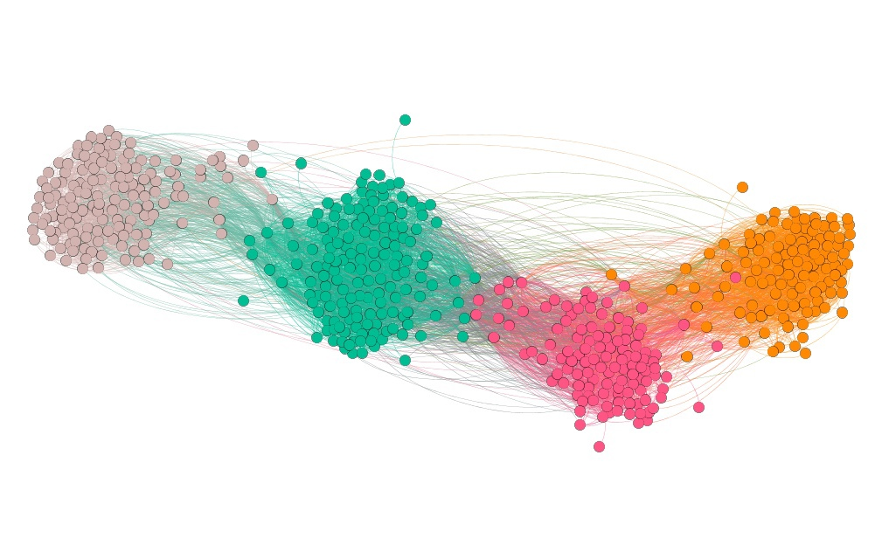

Picture 19. *Philology*. Different colors correspond to clustering as a result of applying ForceAtlas2

## Economics

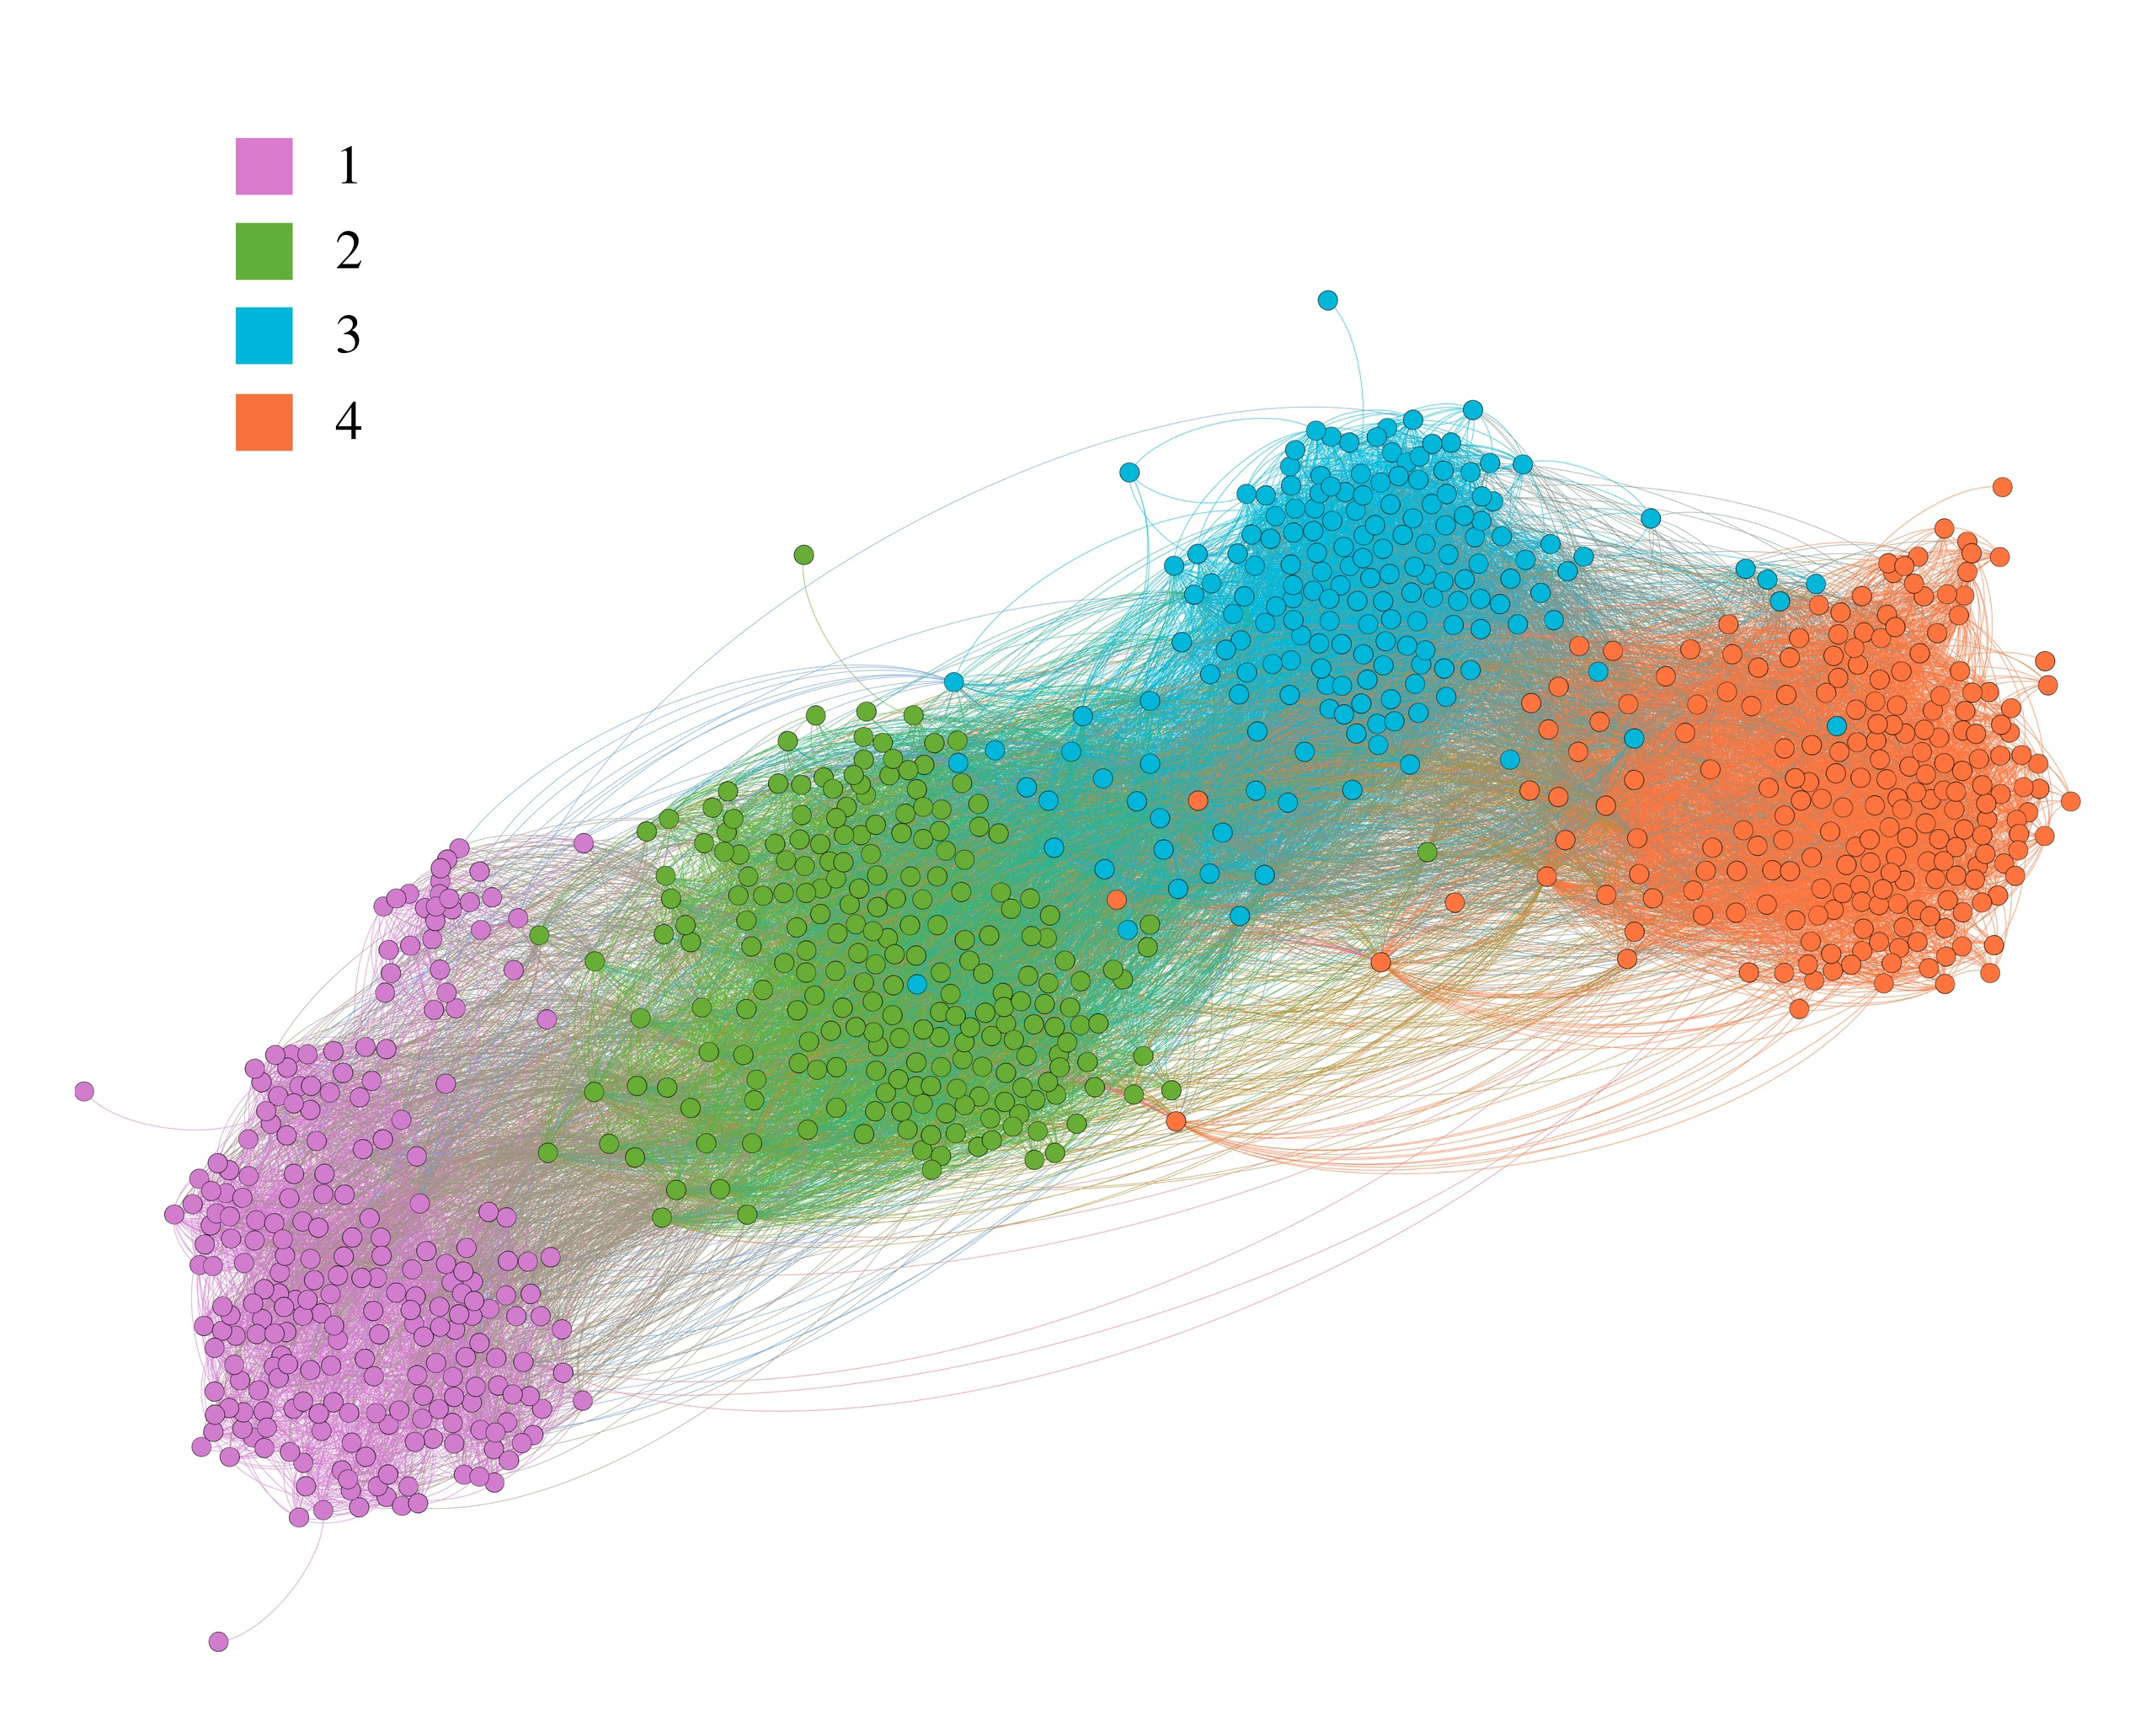

Picture *20*. *Economics*. Different colors correspond to different years (from 1st to 4th)

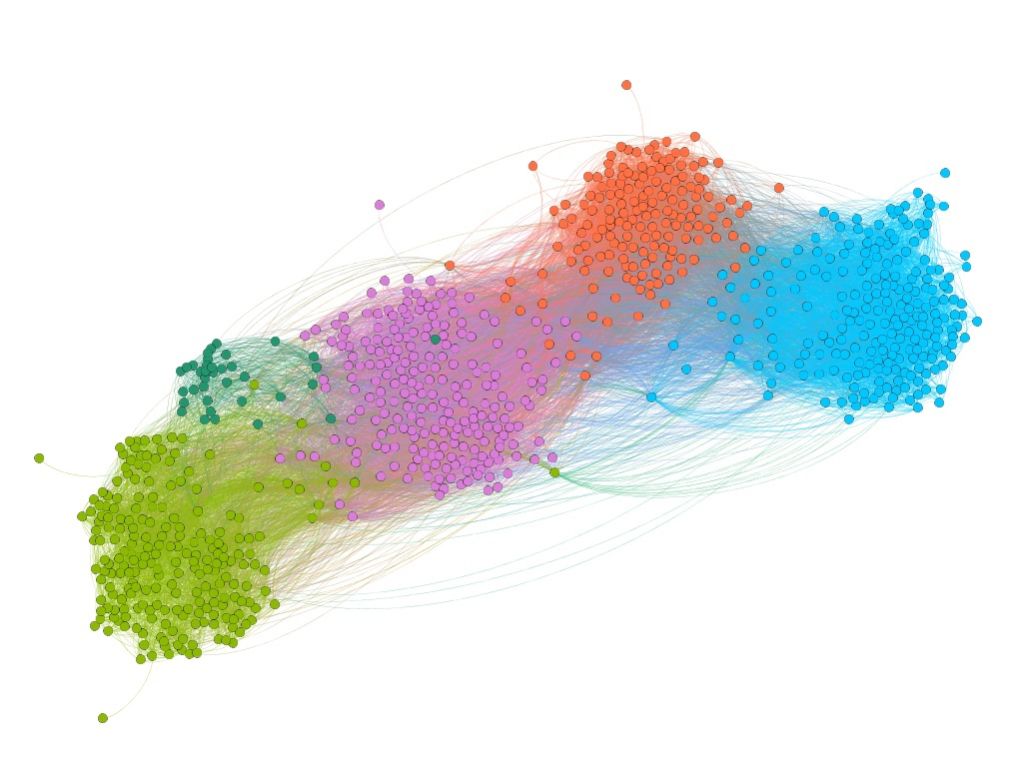

Picture *21*. *Economics*. Different colors correspond to clustering as a result of applying ForceAtlas2

The first interesting point is the significant sparsity of the freshmen, their graph (being already laid out with all the other years) groups students inside into small heaps (perhaps, these are actual study groups).

The second interesting point is that there are 5clusters when coloring according to the belonging to the clusters obtained as a result of maximizing the modularity (this can be seen in the 2nd picture above, a dark green cluster that is next to the light-green one of the freshmen).

Most of the students from that light-green cluster ended up in the purple one (picture on the left, freshmen), still being quite separate from all the other clusters-groups.  
  
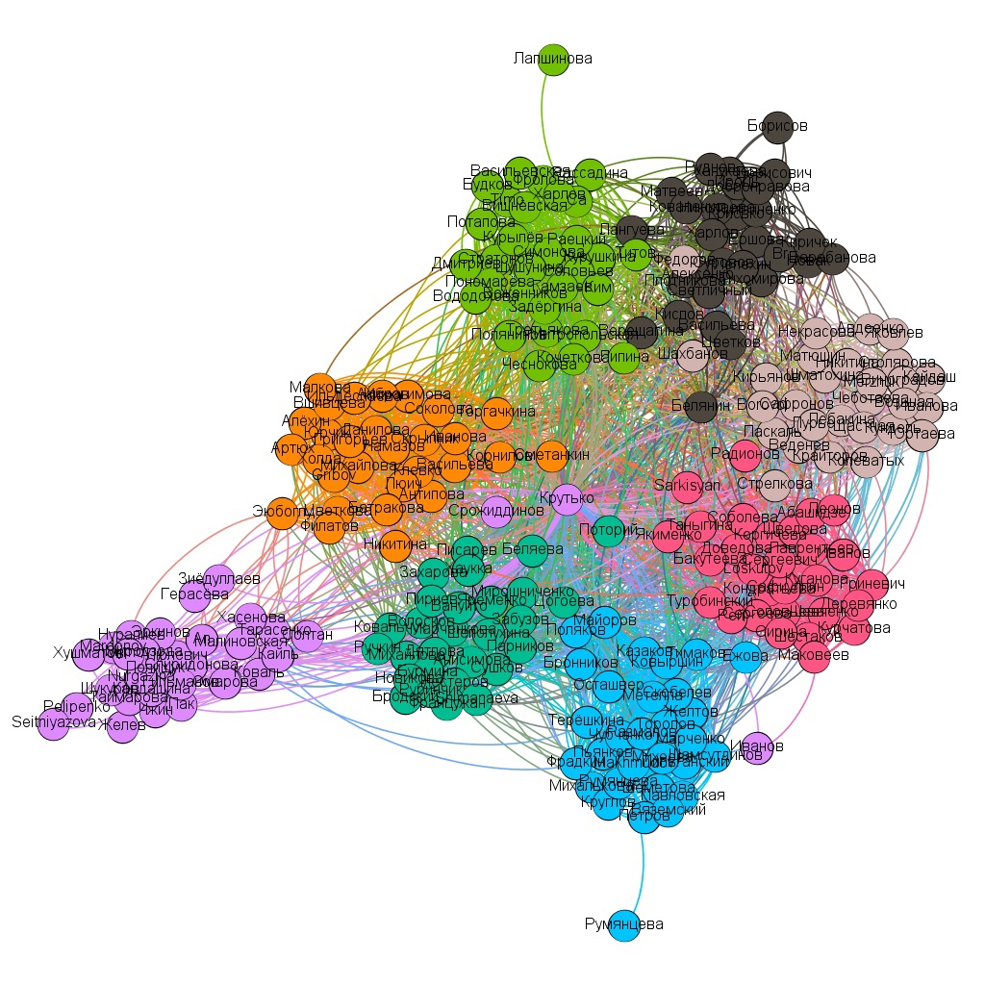Speaking of sparsity, here it is even more visible, the resulting clusters are weakly adjacent to each other, which may indicate some "separation" of the groups from each other.

## Law

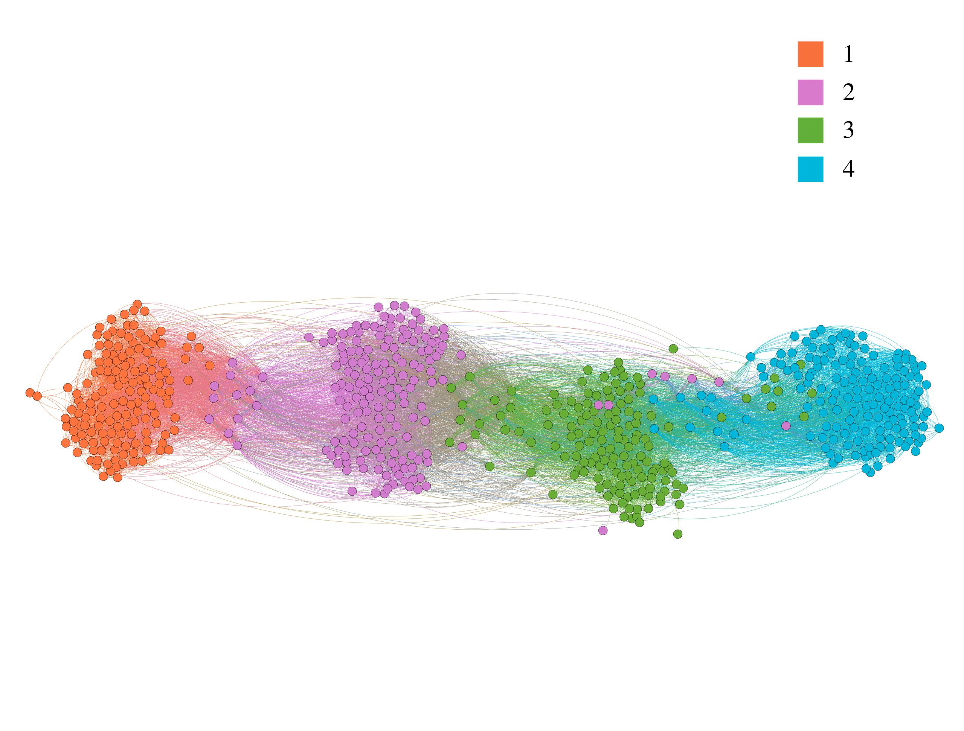

Picture *22*. *Law*. Different colors correspond to different years (from 1st to 4th)

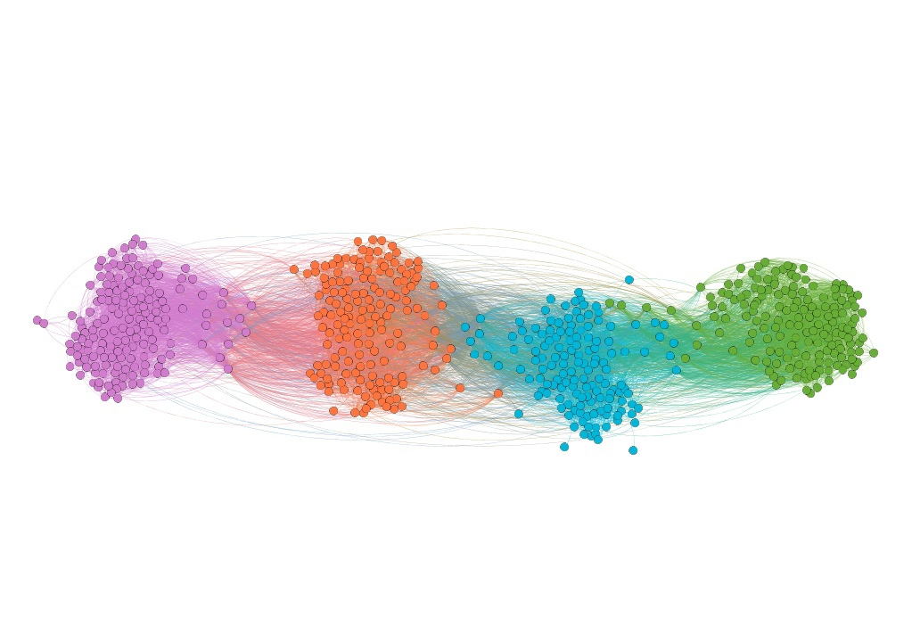

Picture *23*. *Law*. Different colors correspond to clustering as a result of applying ForceAtlas2

The only thing I would pay attention to in the context of the entire Law graph is the second-year cluster, which is too "wide":

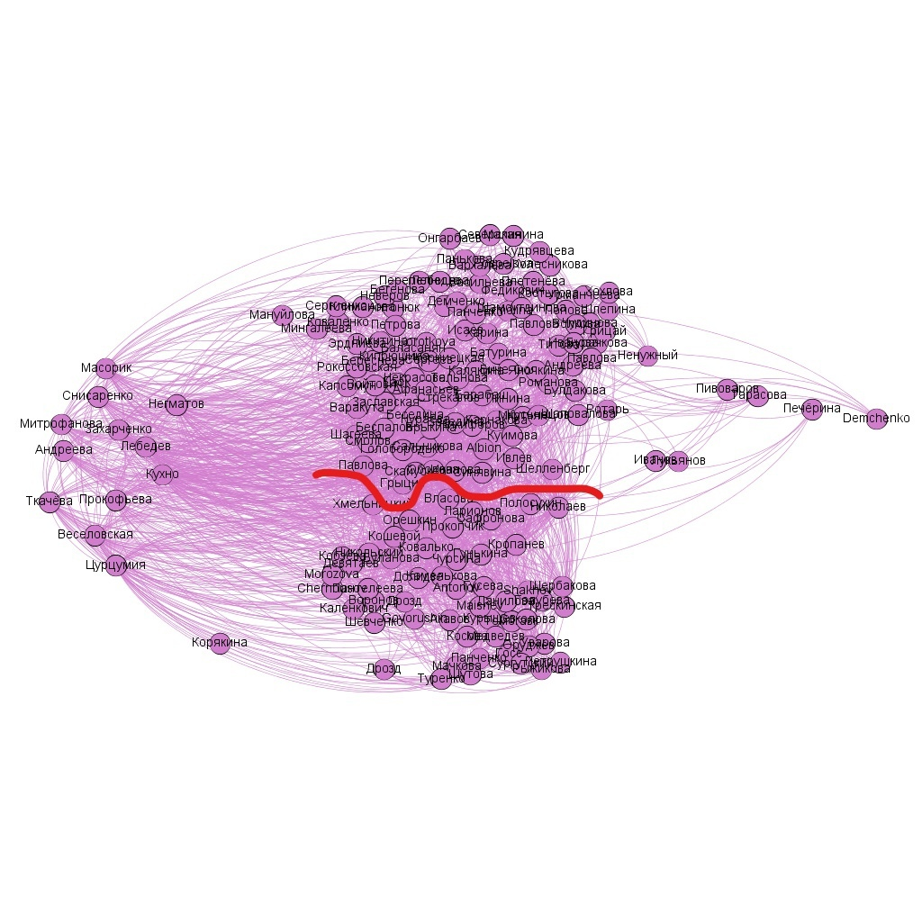

*Picture 24.*

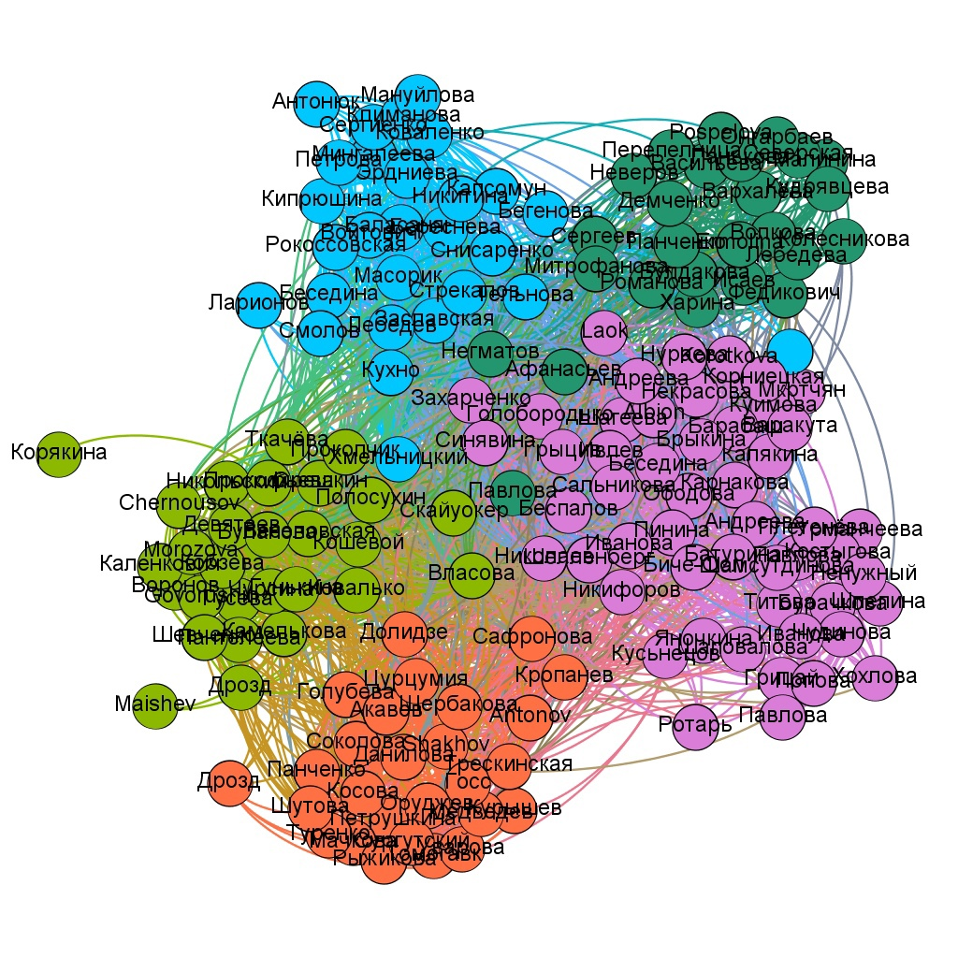

*Picture 25.* Law, 2nd year students. Different colors correspond to clustering as a result of applying ForceAtlas2

It seems that the light-green and orange (2nd picture) clusters just roughly correspond to the split I proposed (1st picture) of the cluster of the sophomores. In general, these 2 clusters (possibly study groups) are relatively distanced from all other students.

**Comparison of programs by different metrics**

### Density

Despite the fact that some programs have a lower density value, we should not forget about the number of students studying in each of these programs (number of vertices) — it is not surprising that the programs with the lowest number of vertices are mostly at the top of the list here.  
  
However, for example, with three times fewer students, "History" has a graph with a density coefficient that is not much higher than that of "Management", which suggests, **on the one hand**, that a substantial share of Management students knows each other (at least online), given there are quite a few of students (note how low the density coefficient is in the case of “Economics”, given the number of students there is close to that in “Management”). The point is not that the indicator itself is high (not high, and it is largely due to weak links through one year [for example, 1 year←→ 3 year] and even weaker links through two years [1 year←→4 year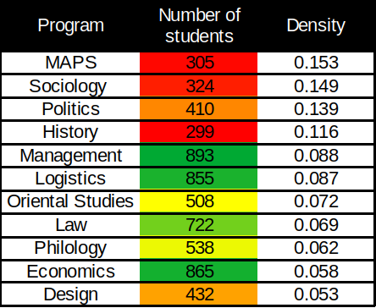]), but that Management keeps it close to “History” or “Logistics”, where significantly fewer students are studying.

**On the other hand**, this suggests that even with the smallest (or close to it) number of History students, not as many students as could know each other (in a sense, we can say that "the potential of a small number of students is not reached in terms of the number of relationships").

Also, according to this metric, “Design” is at the very bottom, and here the interpretation can be the same as in the case of the “History” and “Management”, only here it’s not Management, but Economics, and not History, but Design, (comparison is made based on the number of students studying in each of these programs).

### Global Clustering Coefficient

As mentioned at the beginning, the global coefficient is expected to be of the same degree of smallness as the density, however, unlike the density, it is not as sensitive to the number of vertices, because it evaluates connections (edges).  
  
Let me remind you of the interpretation that I provided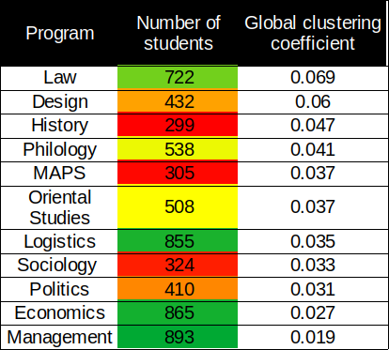 at the beginning of the article for the global clustering coefficient: "How close to reality is the statement 'my friend's friend is my friend' for this group of students?"

Law and Design show the best results on this criterion, but in the case of Design, you also need to take into account the fact that there are only 3 years, so this program could show the best results simply because of this (but this is a mere possibility).

Considering that management students communicate quite closely with each other in reality, it is ironic to see them at the very bottom of the list (next to economics), but it is too early to draw conclusions until we have looked at all three metrics.

In addition, we must not forget what the global coefficient is in fact — if I have a lot of friends (especially if from different years of my program), then I (as a vertex) will greatly lower the value of this metric, if I do not know many of my friends' friends (and I will greatly raise it otherwise).

### Average Clustering Coefficient

I will remind you of the interpretation of this metric given by me at the beginning of the article:  
*"A measure of how tight-knit, on average, student companies are in the context of a given network (in the context of all students-vertices of a given graph)."*  
  
In other words, we can say that the companies of students of MAPS, History and Sociology are relatively most "close-knit". I would also add Politics here, because the graph of this program reports a good density indicator (as well as the other three mentioned programs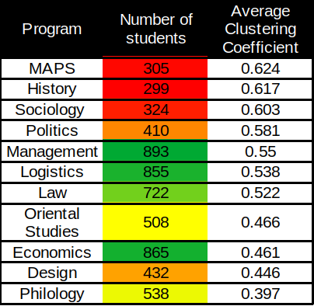).

Can we say that the companies of students of "Philology" are the least “friendly”? Not exactly, we can't say for sure.

First, we should not forget that we are analyzing a network of contacts, not real relationships.

Secondly, it may turn out, for example, that it’s often the case when a student adds a lot of people that are majoring in the same field, but all these people themselves are not connected enough to form a complete subgraph (so that everyone is familiar with each other). If this second assumption holds, then this would indicate some "promiscuity" in this network, but it is impossible to say for sure.

Third, it may turn out that students are actually friends in small companies but make a lot friends on VK which they just know, i.e., these are so-called "weak" connections, and in this case you can not call the students' companies “unfriendly”, but you can not say for sure.

Again, when I say friendly/close-knit, I mean only what was indicated at the beginning of the article (see the section "Used metrics and their interpretation").

Before finishing this section, I will give a table with the same metrics, calculated separately for all years of all programs:

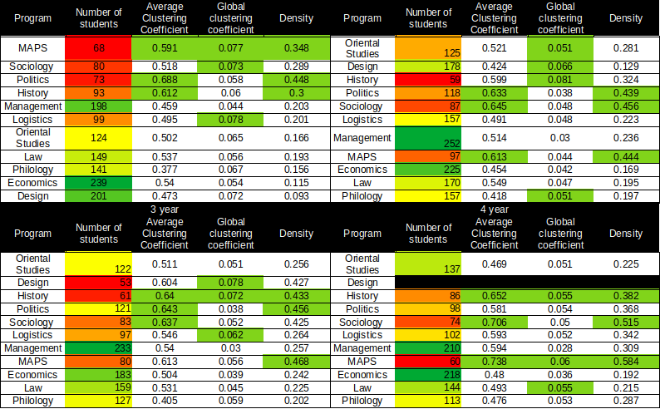

### Average number of handshakes

Here I would limit myself to the fact that this metric shows rather good values for all the programs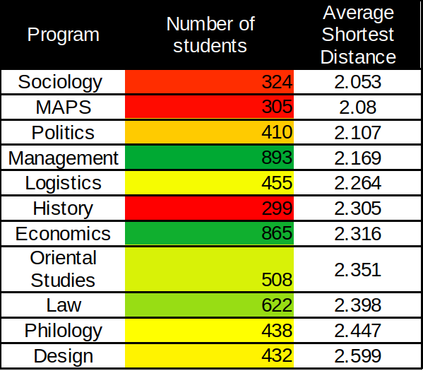, they fall within the range of [2; 2.6], i.e., all students know all the students of their OP through about one person! (the shortest path is a connection, i.e., edges; if I have a friend Vasya who knows Petya, and I don't know Petya, then there are two connections between me and Petya [i→Vasya and Vasya→Petya], i.e. I know it through two edges, or through one vertex).

However, it is worth paying attention to the fact that this metric is more significant the more students there are in the graph (since it is more difficult to know everyone on average through about one person in a large group of students, say, in a faculty).

## Comments

### General comments

When writing this article, I did not set myself a task of doing serious research — I did not have a goal of putting a “label” on a group of students using the given metrics, or offering something to HSE to improve student cohesion.

For me, it's just a fascinating experience to look at real people, even by analyzing their VK accounts, their interactions, give some characteristics where it's interesting, and then share it with everyone! In addition, it helps to prove to myself that I am able to do something more or less interesting and bring it to the end.

### Further research is needed

From time to time, while working with data and formulating some tasks, there were moments when I thought "it would be cool to see more of this", but often I stopped myself, because I can’t cover everything at once. More extensive research would have taken additional time, which I would hardly have had, so in order to publish this article, I had to give up some ideas, and here are some of them.

**1) Another global clustering coefficient**

The global clustering coefficient is based on the calculation of triplets, in particular, the estimation of the probability that the triplets in the graph are closed, but it is not necessary to use triplets. Thus, the authors of [this paper](https://arxiv.org/abs/1704.03913) generalize the global clustering coefficient using higher-order cliques (a clique is a fully connected subgraph of a given graph), supporting this by the fact that there may not be enough cliques on three vertices to understand relatively complex networks.

That is, one could also use the probability that, for example, the four vertices are closed in a given graph, but does this make sense in the context of student relationships?

Perhaps such structures would occur more frequently, and / or we could at least interpret them as the frequency of the appearance of companies of not 3, but 4, 5 or more people, thus identifying larger student groups.

In turn, based on this, we could build an algorithm that divides the graph into clusters in order to maximize the number of such groups for subsequent visualization of these clusters — this could tell us something else about specific people (based on what groups they were assigned to).

**2) Other metrics**

There’s more fish in the sea. You could find other metrics (or make them yourself), which could be more sophisticated, which would help to compare groups of students of different majors or years with each other or tell something else.

**3) The vertices with the highest centrality**

The centrality is the degree of how many other vertices a given vertex connects to each other. In the context of student interactions, this can be interpreted not only as the "inclusiveness" of a student, but also as the degree to which a given student is important in terms of connecting other students to each other.

**4) Community analysis**

At the beginning of the article, I mentioned that I also extracted the communities that each student was subscribed to on VK. This data could also be used to characterize the interests of certain groups of students - for descriptive purposes, insights about the similarity of different groups, or, for example, to recommend students to each other.

**5) Analysis with additional data (weighted graph)**

The presence of students in each other's friends does not say much, but more information is given to us by whose photos students like, whose posts/photos they comment, and more. So, we could take into account a number of features of this kind in order to assess an extent to which the communication between two students is actually important. Moreover, we may no longer just talk about a weighted graph, but about a weighted directed graph, since students may treat each other differently.

**6) Comparison with other universities**

At last, it would be possible to do the same work with students from other universities in St. Petersburg, so you could say, for example, how truly close-knit HSE students are in contrast to students from other universities.

## In conclusion

I would like to finish the article by saying that all educational programs are different, and once again note that in this text I analyzed connections of students taken from a social network, and not real relationships. It may be that even two best friends in reality are not “friends” on VK.

I have not used all the existing metrics, and the ones used do not provide an exhaustive description of the student communities, so even those educational programs for which some metrics are of relatively low values should not automatically be considered as "worst" or even "unfriendly".

Thank you for reading this,

@bouquet_of_phrases :)

1. Higher School of Economics. Also, throughout the text, whenever “HSE” is used, only St. Petersburg’s campus is implied.
2. Vkontakte (social network).
3. In Russia, the organization of study process is quite different from what may be seen in the Western universities. Particularly, in the beginning of the first year, students are split into groups, so that each student will attend classes with a group that was assigned to her/him for all four/five years (to get a bachelor’s degree). Whenever I use university/study/academic group here, I use it in this sence.
4. At HSE, two curators (sophomores) are assigned to a group of freshmen. Curators’ role is to help their freshmen with “assimilation” at the new University.
5. https://en.wikipedia.org/wiki/Graph_(discrete_mathematics)
6. https://en.wikipedia.org/wiki/Induced_subgraph
7. https://en.wikipedia.org/wiki/Clustering_coefficient
8. https://en.wikipedia.org/wiki/Clustering_coefficient
9. It’s in Russian, so you might want to turn on the captions
10. Colors correspond to communities which themselves represent clusters that were created in such a way that the modularity is optimized (locally maximized)
11. In Russian, we would use a word “course” to indicate a group of students a certain year at a grad school. For example, freshmen (first-year students) would be called “students of first course”. Whenever “year” is used in relation to students as a group, I use it in this particular sense.
12. The original language of this article is Russian, and in Russian the programs were listed in alphabetical order. However, for the sake of preserving the logic of the original narrative, I keep this order as it was.